We Believe
Bible Information Class (BIC)

A class for those interested in membership at St. John’s Lutheran Church or for anyone who would like to learn more about the Bible and the teachings of the Wisconsin Evangelical Lutheran Synod (WELS)
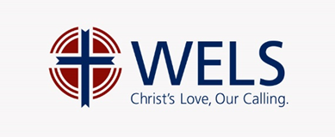

The specific dates and times of the classes vary depending on participants’ schedules, but generally the class is taught three times a year in the following windows. If you are interested in taking the class during one of the windows, you must contact Pastor Birsching before the listed deadline.

October – November January – February May – June
Register by: Sep 21 Register by: Dec 21 Register by: Apr 21

The class is designed to run for six weeks with one lesson a week. Each lesson usually lasts between 60-90 minutes. If necessary, other arrangements can be made.

If interested, please contact Pastor Craig Birsching.

253-355-2574 birschcn@gmail.com

