Unwrapping the First Christmas
What really happened?

Introduction

Every Christmas, the story of Jesus’ birth plays through our minds again. Christmas cards, movies, decorations, and songs seem to illustrate the first Christmas so artfully. If we open our Bibles and read the actual Christmas accounts though, we can be surprised at what we find, and what we don’t find. Jesus’ birth was beautiful and special, but not necessarily in all the ways popular or traditional Christmas culture describes it. Discuss with the people around you some common misconceptions about Jesus’ birth you’ve noticed or heard about over the years.

This Christmas season, we’re going to spend a few weeks unwrapping the first Christmas together to see what really happened. Not so that we can start smashing nativity scenes or rewriting everyone’s favorite Christmas songs, but so we can have a clearer picture of how God carried out his amazing plan of sending the Savior to earth.

Read Luke 1:26-38

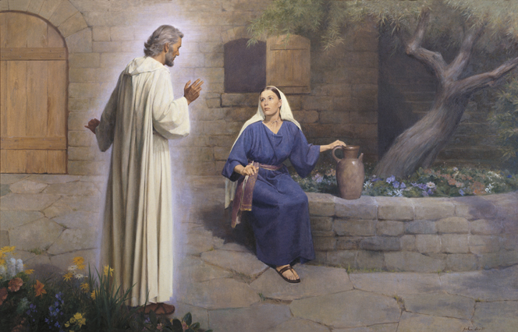
- Though God’s plan went back to before creation, the Christmas story really began with Gabriel’s appearance to Mary. What are some things that stand out to you in these verses?

- It can be easy to skip over this account and jump right to the stable in Bethlehem. There are some incredibly important details recorded here though. Name some.

Matthew 1:18-25

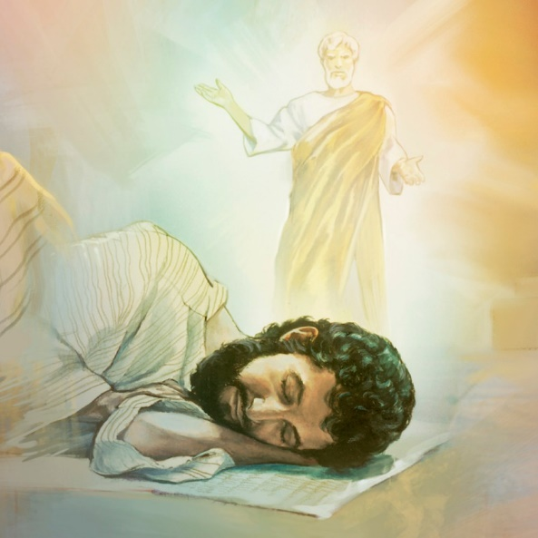
- Of all the Christmas characters, Joseph is probably the most overlooked. What are some possible reasons for that?

- Agree or Disagree? Matthew doesn’t mention a stable, a manger, shepherds, or any of the colorful details which are popular at Christmas time because those things really aren’t that important.

Luke 2:1-7

- Compare these verses with the following pictures. What assumptions do the artists make which might not be accurate?
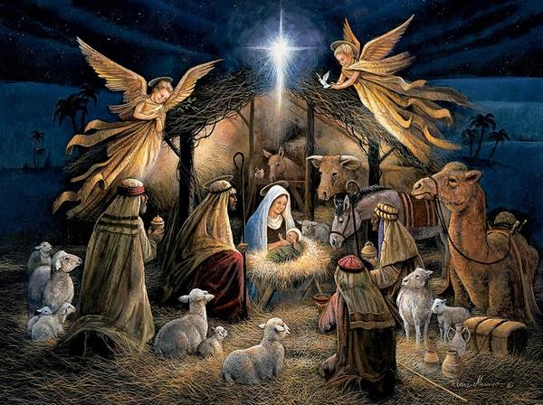

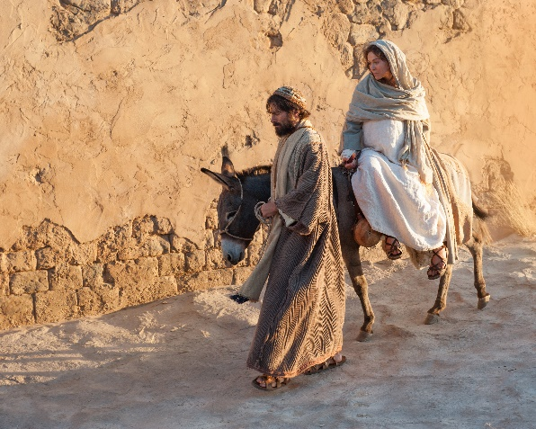

- Guesswork and assumptions aside, what important facts does God make clear to us in these verses?

Luke 2:8-20

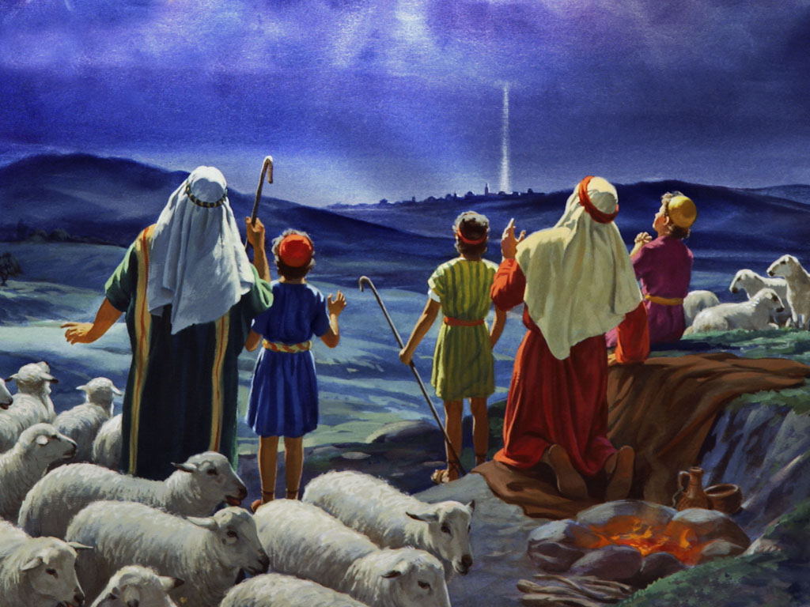
- Name your favorite part of these verses and explain why you like it.

- Did the angels sing when they appeared to the shepherds or not? Defend your answer.

- These verses give us pause as we think about Jesus’ birth in Bethlehem often being described as “humble” and “lowly”. Explain.

Luke 2:21-24

“After the Lord brings you into the land of the Canaanites and gives it to you, as he promised on oath to you and your ancestors, you are to give over to the Lord the first offspring of every womb. All the firstborn males of your livestock belong to the Lord. Redeem with a lamb every firstborn donkey, but if you do not redeem it, break its neck. Redeem every firstborn among your sons.” - Exodus 13:11-13

The Lord said to Moses, “Say to the Israelites: ‘A woman who becomes pregnant and gives birth to a son will be ceremonially unclean for seven days, just as she is unclean during her monthly period. On the eighth day the boy is to be circumcised. Then the woman must wait thirty-three days to be purified from her bleeding. She must not touch anything sacred or go to the sanctuary until the days of her purification are over. If she gives birth to a daughter, for two weeks the woman will be unclean, as during her period. Then she must wait sixty-six days to be purified from her bleeding. ‘When the days of her purification for a son or daughter are over, she is to bring to the priest at the entrance to the tent of meeting a year-old lamb for a burnt offering and a young pigeon or a dove for a sin offering. He shall offer them before the Lord to make atonement for her, and then she will be ceremonially clean from her flow of blood. ‘These are the regulations for the woman who gives birth to a boy or a girl. But if she cannot afford a lamb, she is to bring two doves or two young pigeons, one for a burnt offering and the other for a sin offering. In this way the priest will make atonement for her, and she will be clean.’” - Leviticus 12:1-8

- These verses usually don’t make it into any Children’s Christmas services. Why not? What are some reasons we should still keep them in mind at Christmas time?

Matthew 2:1-12

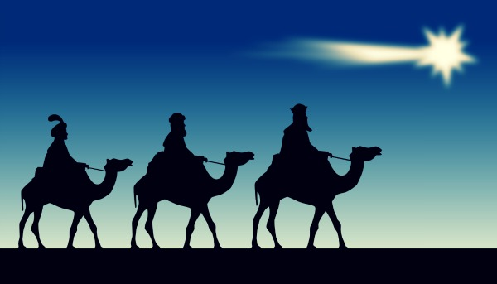
- What are some common misconceptions about the Magi?

- The Magi and the star they followed are standard features in almost every nativity scene. As nice as they all look there, they probably don’t belong. What are some Biblical clues which lead us to think that?

- We don’t know exactly who these Magi were or what caused them to follow a star to Bethlehem in search of “the King of the Jews”. However, consider the following Bible passages.

Then he spoke his message: “The prophecy of Balaam son of Beor, the prophecy of one whose eye sees clearly, the prophecy of one who hears the words of God, who has knowledge from the Most High, who sees a vision from the Almighty, who falls prostrate, and whose eyes are opened: “I see him, but not now; I behold him, but not near. A star will come out of Jacob; a scepter will rise out of Israel. He will crush the foreheads of Moab, the skulls of all the people of Sheth. Edom will be conquered; Seir, his enemy, will be conquered, but Israel will grow strong. A ruler will come out of Jacob and destroy the survivors of the city.” - Numbers 24:15-19

Then the king placed Daniel in a high position and lavished many gifts on him. He made him ruler over the entire province of Babylon and placed him in charge of all its wise men. – Daniel 2:48

It pleased Darius to appoint 120 satraps to rule throughout the kingdom, with three administrators over them, one of whom was Daniel. The satraps were made accountable to them so that the king might not suffer loss. Now Daniel so distinguished himself among the administrators and the satraps by his exceptional qualities that the king planned to set him over the whole kingdom… So Daniel prospered during the reign of Darius and the reign of Cyrus the Persian. - Daniel 6:1-3, 28

Matthew 2:13-23

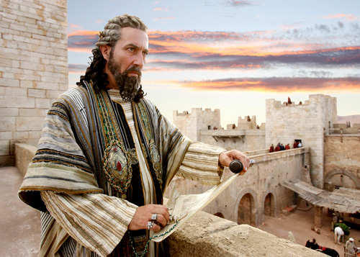
- These verses describe the darker part of the first Christmas which most (all?) Christmas decorations, songs, and services skip over. King Herod murdering the babies of Bethlehem certainly doesn’t do much for our “Christmas spirit”. These verses still give us some important details about our Savior though. Name some.

Cleaning Up

- Discuss with the people around you how you would complete the following statements.

- The most interesting thing I learned from this study was ______________________________.

- As I celebrate Christmas this year, I want to remember _______________________________.

