Struggling with Suffering
A Study on Job: Part 3

Introduction
On your own, take two minutes to write down ways God has shown himself to be an awesome God. Feel free to draw from the Bible, your own life, or anything else. Then consider the following question:

Would this be a good exercise to do when we are suffering? Why or why not?

Read Job 32:1-22

- Elihu, a character we know very little about, enters the conversation between Job, Eliphaz, Bildad, and Zophar. What are some things you like about his opening words? Is there anything you don’t like?

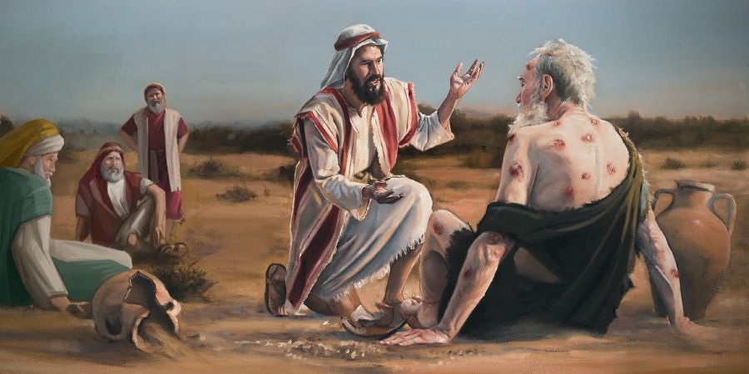

Read Job 33, 34, and 36

- With your group, work through your assigned chapter and answer the following questions:

- Are there any words or truths in this chapter which might be helpful reminders in the midst of suffering? Explain.

- Based on this chapter, how would you summarize Elihu’s advice to Job?

Read Job 37:1-24

- Apparently, a real storm was brewing while Elihu spoke (see 38:1), which maybe explains why he chose the words he did. This chapter seems to support the idea that Elihu’s long speech really just set the stage for God to speak. What are some ways we can “set up God” when we’re talking with people who are suffering?

Apply
- One of the go-to passages Christians quote during suffering is Romans 8:28: “And we know that in all things God works for the good of those who love him, who have been called according to his purpose.” That passage definitely describes God’s awesomeness, but what cautions should we keep in mind before/as we share it?

