Struggling with Suffering
A Study on Job: Part 2

Introduction

Last week we talked about what a blessing friends can be when we’re suffering. Sometimes though, people mean well, but actually make our suffering worse instead of better. Discuss with the people around you some examples of when this might be true or some times you’ve found it to be true in your own life.

Read Job 2:11-13

- Agree or Disagree? The best thing we can with someone who is suffering is to just sit with them in silence.

Read Job 3:1-2, 11-26

- Is this the same guy who wowed us last week with his confessions of faith in the midst of severe suffering? What are some possible reasons Job’s talking a little differently now than he was earlier?

- Is it wrong for a suffering Christian to long for death? Explain your answer.

Read Job 4:1-9

- Eliphaz is the first friend to speak to Job. Summarize what he said.

Read Job 6:1-4, 8-10, 24-30

- According to these verses, what are some things Job wants?

Read Job 8:1-7, 20-22

- Bildad joins the conversation and really repeats Eliphaz’s argument with even less tact. What are some things Bildad says which we would not want to repeat to our suffering friends?

Read Job 11:1-6, 13-20

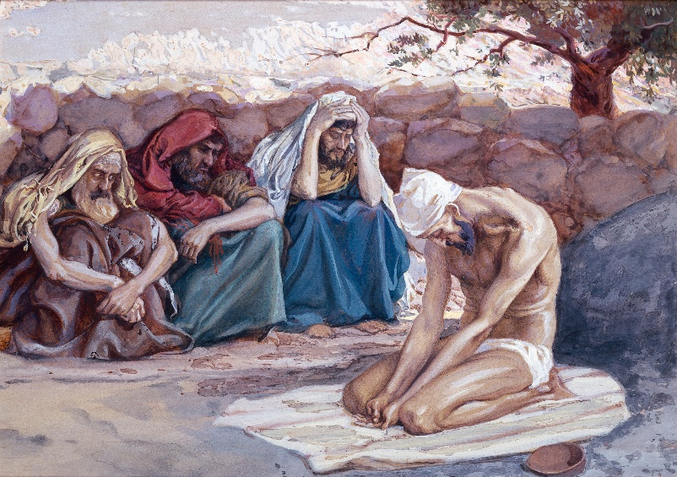
- After another response by Job, the third friend, Zophar, chimes into the conversation and agrees with Eliphaz and Bildad. Basically, the worldview of the three friends comes down to this: If you do good, God will bless you with good things. If you do bad, God will punish you with bad things.

The next 20 chapters of the book then revolve around Eliphaz, Bildad, and Zophar trying to convince Job of this truth, while Job continues to deny it. Job’s main arguments are:
1. You can’t put the almighty God in the little predictable box you’re trying to put him in.
2. Your worldview can’t be correct because I’ve lived a life that is very good in God’s eyes but I’m suffering terribly.

Discuss with the people around you the following questions:
- What are some major problems with the friends’ understanding of God?

- What are some possible reasons Job’s three friends are arguing for their worldview so strongly?

Job 10:8-12
⁸ “Your hands shaped me and made me.
Will you now turn and destroy me?
⁹ Remember that you molded me like clay.
Will you now turn me to dust again?
¹⁰ Did you not pour me out like milk
and curdle me like cheese,
¹¹ clothe me with skin and flesh
and knit me together with bones and sinews?
¹² You gave me life and showed me kindness,
and in your providence watched over my spirit.
Job 12:13-16
¹³ “To God belong wisdom and power;
counsel and understanding are his.
¹⁴ What he tears down cannot be rebuilt;
those he imprisons cannot be released.
¹⁵ If he holds back the waters, there is drought;
if he lets them loose, they devastate the land.
¹⁶ To him belong strength and insight;
both deceived and deceiver are his.
Job 16:19-21

¹⁹ Even now my witness is in heaven;
my advocate is on high.
²⁰ My intercessor is my friend
as my eyes pour out tears to God;
²¹ on behalf of a man he pleads with God
as one pleads for a friend.

Job 19:25-27
²⁵ I know that my redeemer lives,
and that in the end he will stand on the earth.
²⁶ And after my skin has been destroyed,
yet in my flesh I will see God;
²⁷ I myself will see him
with my own eyes—I, and not another.
How my heart yearns within me!

- Job didn’t get a lot of encouragement from his three friends, but he relied on what he knew about God. What are some truths in these verses which might be worth mentioning to a suffering Christian?

- The next time one of my friends is suffering I’m going to __________________________________.

