Harvest Strategy
Part 2: The What (continued)

Read John 4:4-26
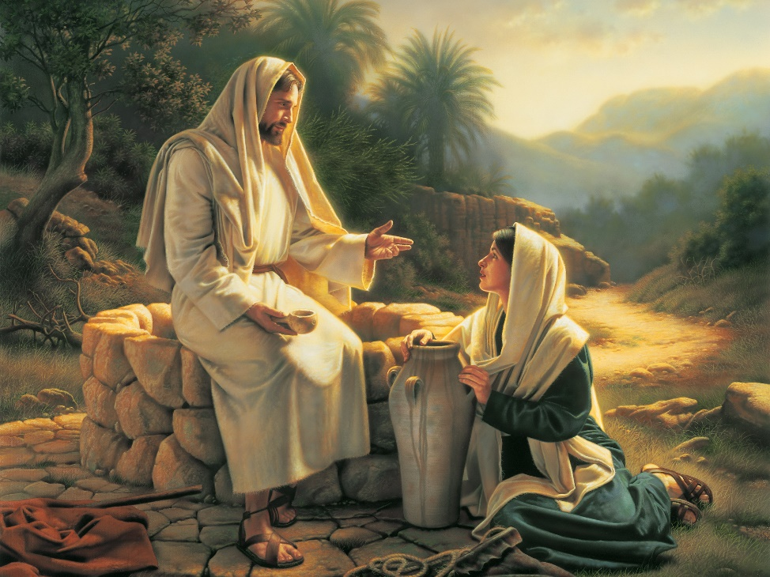
⁴ Now he had to go through Samaria. ⁵ So he came to a town in Samaria called Sychar, near the plot of ground Jacob had given to his son Joseph. ⁶ Jacob’s well was there, and Jesus, tired as he was from the journey, sat down by the well. It was about noon. ⁷ When a Samaritan woman came to draw water, Jesus said to her, “Will you give me a drink?” ⁸ (His disciples had gone into the town to buy food.)
⁹ The Samaritan woman said to him, “You are a Jew and I am a Samaritan woman. How can you ask me for a drink?” (For Jews do not associate with Samaritans.) ¹⁰ Jesus answered her, “If you knew the gift of God and who it is that asks you for a drink, you would have asked him and he would have given you living water.”
¹¹ “Sir,” the woman said, “you have nothing to draw with and the well is deep. Where can you get this living water? ¹² Are you greater than our father Jacob, who gave us the well and drank from it himself, as did also his sons and his livestock?” ¹³ Jesus answered, “Everyone who drinks this water will be thirsty again, ¹⁴ but whoever drinks the water I give them will never thirst. Indeed, the water I give them will become in them a spring of water welling up to eternal life.”
¹⁵ The woman said to him, “Sir, give me this water so that I won’t get thirsty and have to keep coming here to draw water.” ¹⁶ He told her, “Go, call your husband and come back.” ¹⁷ “I have no husband,” she replied. Jesus said to her, “You are right when you say you have no husband. ¹⁸ The fact is, you have had five husbands, and the man you now have is not your husband. What you have just said is quite true.”
¹⁹ “Sir,” the woman said, “I can see that you are a prophet. ²⁰ Our ancestors worshiped on this mountain, but you Jews claim that the place where we must worship is in Jerusalem.” ²¹ “Woman,” Jesus replied, “believe me, a time is coming when you will worship the Father neither on this mountain nor in Jerusalem. ²² You Samaritans worship what you do not know; we worship what we do know, for salvation is from the Jews. ²³ Yet a time is coming and has now come when the true worshipers will worship the Father in the Spirit and in truth, for they are the kind of worshipers the Father seeks. ²⁴ God is spirit, and his worshipers must worship in the Spirit and in truth.”
²⁵ The woman said, “I know that Messiah” (called Christ) “is coming. When he comes, he will explain everything to us.” ²⁶ Then Jesus declared, “I, the one speaking to you—I am he.”

- Discuss with the people around you what we can learn from Jesus about how he specifically shared Law and Gospel (sin and grace) with the Samaritan woman.

Law –

Gospel-

- Create a list of regular, everyday conversation starting points with families in your school, preschool, or community.

- Building off of #2, now create a list of conversation transitions. How will you turn those regular, everyday conversation into faith conversations?

- Identify specific times or occasions that present great opportunities for faith conversations with the families in your school, preschool, or community.

- Discuss the following questions with the people around you.

- What are the current ways we are communicating with our school and preschool families? What, if any, are some ways we can do a better job of communicating with them regularly?

- What are some current ways we are connecting our school and preschool families with the Means of Grace (the gospel in Word and Sacrament)? What, if any, are some ways we can do a better job of connecting them to those Means?

