Church Check-up
#8 Personally Own Our Mission
Quotations taken from Thom Rainer’s books “Autopsy of a Deceased Church” and “Breakout Churches” for discussion.

Homework from Lesson #7: Minister with Excellence

Complete the following statement with at least three answers: When a church is truly ministering with excellence, I would expect it to…

St. John’s Vision and Mission Statements (unofficial)

Vision – What will the world look like around us if/when we achieve our mission?

Disciples of all nations following the Triune God.

Mission – What are we doing right now to accomplish our vision?

Providing excellent education to God’s children for this life and the next.

Discuss

- Today we wrap up our eight-week study on our ministry at St. John’s. Discuss the following possible reactions with the people around you. What are some things you like or dislike about them?

- “Wow! This new mission is exciting! I can’t wait to see how the Pastor and leaders carry it out.”
It’s your mission too! You need to be involved.
- “I’m not sold on this whole ‘mission’ concept. I’m going to talk with some other members and see what they think.”
That’s fine, but make sure your talk is loving, not negative
- “I’m going to fully support this new mission. Whatever Pastor tells me to do, I’m going to do it.”
Don’t just blindly follow, think about things and discuss them
- “I’m all for the new mission, as long as none of my favorite ministries have to change.”
You’re not really for the mission then…
- “Once these new plans start happening, the church and school are going to be so much better! I’m so glad we found some solutions.”
These plans aren’t going to fix all the problems. We need to keep working, praying, and making changes to ourselves
Acts 2:42-47

42 They devoted themselves to the apostles’ teaching and to fellowship, to the breaking of bread and to prayer. 43 Everyone was filled with awe at the many wonders and signs performed by the apostles. 44 All the believers were together and had everything in common. 45 They sold property and possessions to give to anyone who had need. 46 Every day they continued to meet together in the temple courts. They broke bread in their homes and ate together with glad and sincere hearts, 47 praising God and enjoying the favor of all the people. And the Lord added to their number daily those who were being saved.

- We looked at this description of the early Christian church in Lesson 3: Listen to the Doctor. What are some good reminders these verses give us as we each think about personally owning our congregation’s mission?
Notice all the plurals! (they, everyone, together, all, etc.) / It’s not just the mission of the church leaders to keep the church functioning. Everyone needs to participate

- Agree or Disagree? St. John’s mission of providing excellent education to God’s children for this life and the next will fail unless the whole congregation gets behind it.
We don’t necessarily need every single person behind it, but the more people who invest, the better

Quotes for Discussion

“Every one of the fourteen autopsied churches had some level of this problem before they died. A significant number of the members moved the focus from others to themselves. And when a church moves in that direction, it is headed for decline then death. The decline may be protracted, and the death may be delayed. But it is inevitable. The church will die.” (Autopsy of a Deceased Church p. 49)

“Membership in the church is not country club membership. It’s not about paying your dues and getting perks. It’s like Paul described in 1 Corinthians 12:12-31. We are members of the body of Christ. We do not exist to serve ourselves; instead, we exist for the greater good of the body. Members of dying churches did not get that. For most of the members, their affiliation with the church focused around their desires and needs. And, as the church got closer to death, the intensity of their arguments and demands for their preferences grew. A church by definition is a body of believers who function for the greater good of the congregation. In essence, when church members increasingly demand their own preferences, the church is steadily not becoming the church. It is therefore neither surprising nor unexpected, at least from an observer’s point of view, when the church closes its doors. The church really died before then because its members refused to be the church.” (Autopsy of a Deceased Church p. 51-52)

“[The members of the comparison churches] might believe that Christ is the only way of salvation, but they are unwilling or unable to share the gospel with nonChristians. In contrast, the majority of those we interviewed in the breakout churches were passionate about reaching people for Christ personally. They did not expect all evangelism to be done by the staff or a select few in the church.” (Breakout Churches p. 177)

- Discuss these quotes with the people around you. What are some things that strike you?
The #1 killer of churches is selfishness / consumer mindset vs servant mindset / a church can stop being a church long before it closes its doors / personal evangelism vs church evangelism / the closer a church is to dying, the more its members argue and fight

- What are some practical ways we can shift the focus of our church from ourselves to others?
Get into the Word / look for ways to serve / identify our “babies” and work on letting go / remember what really matters (gospel proclamation) / listen before speaking or complaining / look for the needs of others instead of personal wants

Colossians 3:12-17, 4:2-6
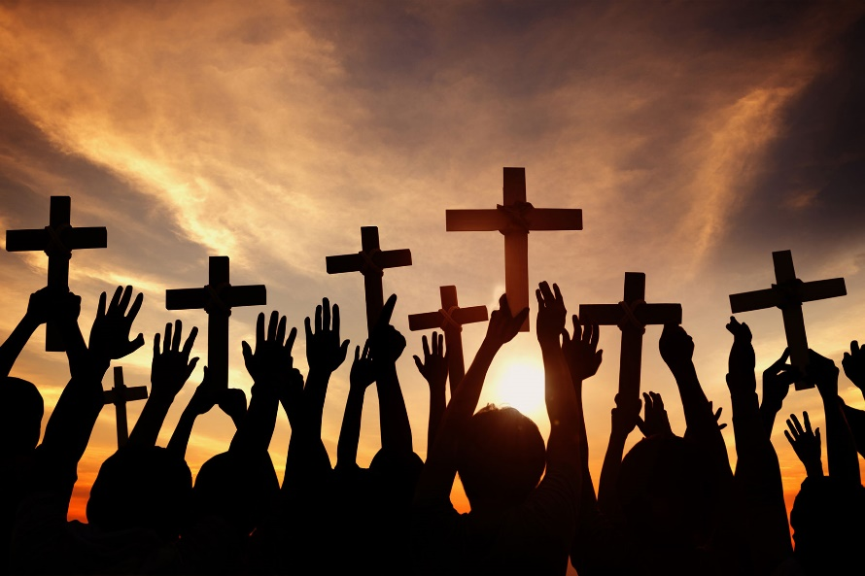
12 Therefore, as God’s chosen people, holy and dearly loved, clothe yourselves with compassion, kindness, humility, gentleness and patience. 13 Bear with each other and forgive one another if any of you has a grievance against someone. Forgive as the Lord forgave you. 14 And over all these virtues put on love, which binds them all together in perfect unity.

15 Let the peace of Christ rule in your hearts, since as members of one body you were called to peace. And be thankful. 16 Let the message of Christ dwell among you richly as you teach and admonish one another with all wisdom through psalms, hymns, and songs from the Spirit, singing to God with gratitude in your hearts. 17 And whatever you do, whether in word or deed, do it all in the name of the Lord Jesus, giving thanks to God the Father through him.

2 Devote yourselves to prayer, being watchful and thankful. 3 And pray for us, too, that God may open a door for our message, so that we may proclaim the mystery of Christ, for which I am in chains. 4 Pray that I may proclaim it clearly, as I should. 5 Be wise in the way you act toward outsiders; make the most of every opportunity. 6 Let your conversation be always full of grace, seasoned with salt, so that you may know how to answer everyone.
- Discuss these verses with the people around you. What are at least five things every one of us can start intentionalizing right now to help carry our congregation’s mission?
Be kind / forgive / unite in love / be at peace / be thankful / let Word dwell richly among us / teach, admonish, sing / do everything for God / pray (devotedly) / pray for leaders / be wise toward outsiders / talk with grace

Other ways you can help

- Talk about these Bible studies with other members who weren’t here. (Help bring them on board.)

- If you are involved in a ministry, program, or event (or multiple ones), think about ways to better connect it/them to our mission (Providing excellent education to God’s children for this life and the next.)

- If you aren’t really involved in any ministries, programs, or events, prayerfully consider where you might be able to use your gifts.

- Keep brainstorming ways to improve what we do here at St. John’s. (This study was only the beginning!)

- Rededicate yourself to worship, Bible study, and prayer and encourage others to do the same. (Remember the spiritual side of things.)

- Attend the next four Sunday Bible studies and help us craft our Harvest Strategy for the school and preschool (specific ways we are going to use our school for outreach).

- Look at Jesus and remember why we are here. We are members of this church because we want to serve God and others, not because we want to be served.

- Other?

Homework

Fill out the Church Readiness Inventory from Thom Rainier’s Breakout Churches. Identify areas where St. John’s has already been richly blessed, and areas where we can improve.
Not about “making St. John’s great again”, but about trying to better serve the Lord / meant to help us identify areas we need to improve / not the final word on our ministry

