Church Check-up
#4 Learn from the Past, but Look to the Future
Quotations taken from Thom Rainer’s books “Autopsy of a Deceased Church” and “Breakout Churches” for discussion.

Homework from Lesson #3: Listen to the Doctor

Complete the sentence with at least three goals. In order to make the gospel a higher priority in my life and at St. John’s, I want to…

The Golden Days

- Discuss with the people around you the following questions: What years would you say qualify as St. John’s “golden years”? Why?
The years still to come! Being a Christian means being an optimist and trusting that God has future blessings for us

Hebrews 11:1-16

1 Now faith is confidence in what we hope for and assurance about what we do not see. 2 This is what the ancients were commended for.

3 By faith we understand that the universe was formed at God’s command, so that what is seen was not made out of what was visible.

4 By faith Abel brought God a better offering than Cain did. By faith he was commended as righteous, when God spoke well of his offerings. And by faith Abel still speaks, even though he is dead.

5 By faith Enoch was taken from this life, so that he did not experience death: “He could not be found, because God had taken him away.” For before he was taken, he was commended as one who pleased God. 6 And without faith it is impossible to please God, because anyone who comes to him must believe that he exists and that he rewards those who earnestly seek him.

7 By faith Noah, when warned about things not yet seen, in holy fear built an ark to save his family. By his faith he condemned the world and became heir of the righteousness that is in keeping with faith.

8 By faith Abraham, when called to go to a place he would later receive as his inheritance, obeyed and went, even though he did not know where he was going. 9 By faith he made his home in the promised land like a stranger in a foreign country; he lived in tents, as did Isaac and Jacob, who were heirs with him of the same promise. 10 For he was looking forward to the city with foundations, whose architect and builder is God. 11 And by faith even Sarah, who was past childbearing age, was enabled to bear children because she considered him faithful who had made the promise. 12 And so from this one man, and he as good as dead, came descendants as numerous as the stars in the sky and as countless as the sand on the seashore.

13 All these people were still living by faith when they died. They did not receive the things promised; they only saw them and welcomed them from a distance, admitting that they were foreigners and strangers on earth. 14 People who say such things show that they are looking for a country of their own. 15 If they had been thinking of the country they had left, they would have had opportunity to return. 16 Instead, they were longing for a better country—a heavenly one. Therefore God is not ashamed to be called their God, for he has prepared a city for them.

- As the author of Hebrews reviews some of the Old Testament heroes of faith, what are some things he makes clear?
They were looking to the future, not the past / they trusted God’s promises / It wasn’t easy (sacrifices) / God blessed them

- Does a healthy faith in God look backward or forward? Explain.
It looks backward at what God has done, and then looks forward in trust and hope

Quote for Discussion

“The most pervasive and common thread of our autopsies was that the deceased churches lived for a long time with the past as hero. They held on more tightly with each progressive year. They often clung to things of the past with desperation and fear. And when any internal or external force tried to change the past, they responded with anger and resolution: ‘We will die before we change.’ And they did. Hear me clearly: these churches were not hanging on to biblical truths. They were not clinging to clear Christian morality. They were not fighting for primary doctrines, or secondary doctrines, or even tertiary doctrines. As a matter of fact, they were not fighting for doctrines at all. They were fighting for the past. The good old days. The way it used to be. The way we want it today.” (Autopsy of a Deceased Church p. 18)

- What are some reasons Christians cling to their church’s past so fervently?
Fear of change / selfishness (I like it this way) / present isn’t very pretty (it was better when…) / lack of vision for the future / weak faith

- Explain. As a church gets closer to dying, its members will often become more and more obsessed with the past.
As things get worse, it’s easy to look at how much better things used to be / everything seems to be falling apart, the past offers something solid

- Agree or Disagree? If a church is going to thrive, it must let go of the past.
A church must be willing to modify its ministry according to their changing resources and opportunities / The past is part of who we are. We should learn from it, but not dwell in it. / The truths our Savior gave us and the actions he did for us were in the past, we need to cling to those!

Story of the Roast

A teenage girl noticed one night before dinner, that her mother always cut the two ends off the roast before putting it in the oven to cook. She asked her mother why she did that and her mother paused for a moment and replied: “I don’t know, honey. That’s always how my mother cooked her roasts. You’ll have to ask grandma.” So the teenage girl went into the other room and found her grandmother. “Grandma, why did you always cut the ends off your roasts before you put them in the oven to cook?” The girl’s grandma chuckled and said: “I don’t know, honey. That’s just always how my mother did it.” Now the teenage girl was really curious, so she called her great-grandmother who was in a nursing home. After catching up with her for a bit, the teenage girl asked. “Great-grandma, why did you always cut the ends off your roasts before you put them in the oven?” The girl’s great-grandmother laughed and said: “Oh, that’s easy. Your great-grandfather and I had a very small oven. The only way to get the roasts to fit in it was to cut the ends off them.”

- It’s a silly story, but what important truth does it illustrate?
People had reasons for why they did things in the past. They probably were good reasons, but they might not apply anymore. We shouldn’t just keep doing things the way they’ve always been done. We need to question everything and ask what the best way to do things now is.

- Discuss the following questions with the people around you.

- One of the most common explanations given for why things are done a certain way at church is: “That’s how we’ve always done it.” (In the two years I’ve been the pastor at St. John’s, I’ve heard this explanation given more times than I can remember.) Instead of just accepting that explanation and continuing the status quo, what are some questions we should ask ourselves?
Why have we done it that way? / What is the best way to do it now? / What is the best way we can proclaim the gospel? / Should we be doing this at all?

- If the members or leaders of a congregation recognize that changes need to be made to one of the church’s beloved ministries, what should their next steps be? Come up with a list of at least five.

- Clarify why the changes need to be made

- Identify who will be most upset by the changes and then talk with them

- Discuss the changes with pastor, other leaders and members

- Stay focused on the big picture (proclaim the gospel)

- Move forward lovingly, but firmly

- “But, Pastor, it doesn’t really matter how we do things. God’s Word is powerful and effective! Our congregation has been proclaiming that Word for over a hundred years and as long as we keep doing that, our church will be just fine.” Respond.
We can’t add to the power of the Word, but we can put barriers in its way / God has also given us wisdom, statistics, and other resources to help us make good decisions

Philippians 2:1-11
Therefore if you have any encouragement from being united with Christ, if any comfort from his love, if any common sharing in the Spirit, if any tenderness and compassion, ² then make my joy complete by being like-minded, having the same love, being one in spirit and of one mind. ³ Do nothing out of selfish ambition or vain conceit. Rather, in humility value others above yourselves, ⁴ not looking to your own interests but each of you to the interests of the others. ⁵ In your relationships with one another, have the same mindset as Christ Jesus:
⁶ Who, being in very nature God, did not consider equality with God something to be used to his own advantage; ⁷ rather, he made himself nothing by taking the very nature of a servant, being made in human likeness. ⁸ And being found in appearance as a man, he humbled himself by becoming obedient to death—even death on a cross!
⁹ Therefore God exalted him to the highest place and gave him the name that is above every name, ¹⁰ that at the name of Jesus every knee should bow, in heaven and on earth and under the earth, ¹¹ and every tongue acknowledge that Jesus Christ is Lord, to the glory of God the Father.
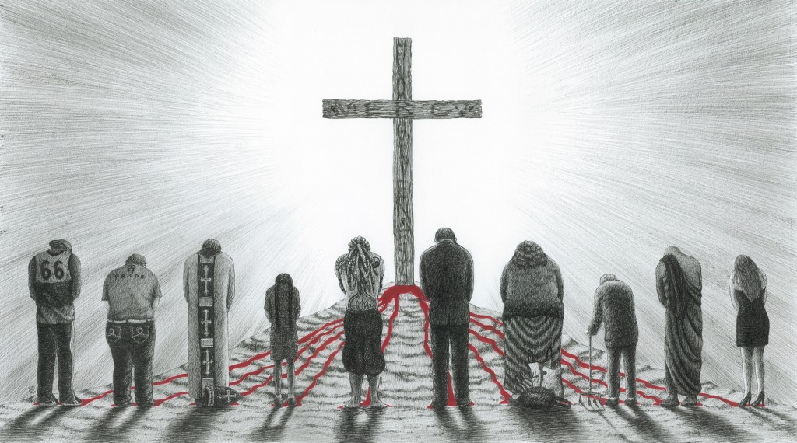
- What are some ways these verses are helpful to a congregation that is struggling to let go of the past?
Be united / don’t be selfish / think of the needs of others / stay focused on Jesus / sacrifices bring blessings / remember what’s waiting for us

Homework

Letting go of the past can be hard, but it enables us to look to the future, and that can be a lot of fun! Complete the sentence with at least two answers. I would be really excited if St. John’s…
Really dove into doing outreach through our school and preschool / Took some maintenance duties off pastor so I can do what I love (working with kids, talking with people)

