Church Check-up
#3 Listen to the Doctor
Quotations taken from Thom Rainer’s books “Autopsy of a Deceased Church” and “Breakout Churches” for discussion.

Homework from Lesson #2: Look Outward, Not Inward

Complete this statement with at least three suggestions. I think St. John’s can do a better job of following Jesus’ Great Commission if we…

Ephesians 6:10-18

10 Finally, be strong in the Lord and in his mighty power. 11 Put on the full armor of God, so that you can take your stand against the devil’s schemes. 12 For our struggle is not against flesh and blood, but against the rulers, against the authorities, against the powers of this dark world and against the spiritual forces of evil in the heavenly realms. 13 Therefore put on the full armor of God, so that when the day of evil comes, you may be able to stand your ground, and after you have done everything, to stand. 14 Stand firm then, with the belt of truth buckled around your waist, with the breastplate of righteousness in place, 15 and with your feet fitted with the readiness that comes from the gospel of peace. 16 In addition to all this, take up the shield of faith, with which you can extinguish all the flaming arrows of the evil one. 17 Take the helmet of salvation and the sword of the Spirit, which is the word of God.

18 And pray in the Spirit on all occasions with all kinds of prayers and requests. With this in mind, be alert and always keep on praying for all the Lord’s people.

- Discuss the following questions with the people around you.

  - What insights do these verses offer on the problems and challenges we’re facing right now at St. John’s?

  - Identify in these verses at least three things we should do to deal with those challenges and problems.

Quotes for discussion
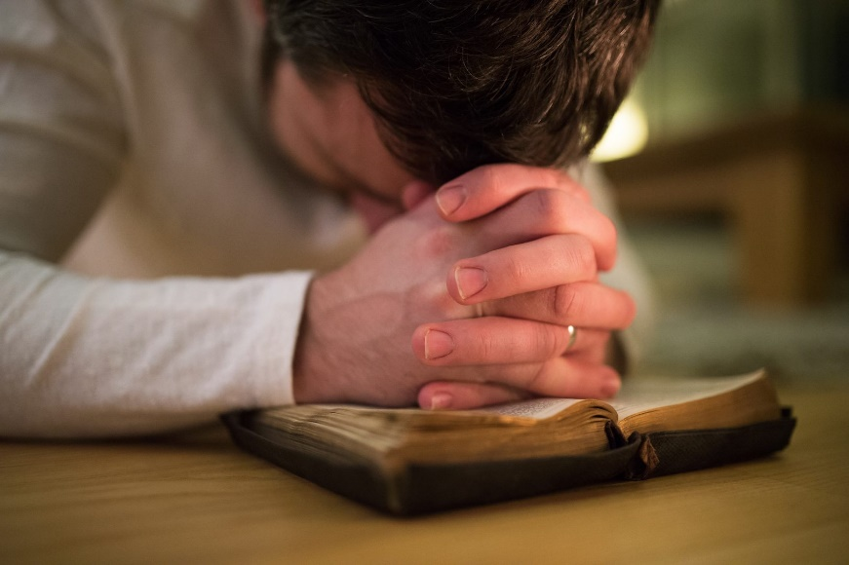
“Not coincidently, prayer and the health of the church went hand in hand. When the church is engaged in meaningful prayer, it becomes both the cause and the result of greater church health.” (Autopsy of a Deceased Church p. 66)

“In a previous study, our research found a direct correlation between time spent in sermon preparation and evangelistic effectiveness. In another study, we found that one of the key reasons the unchurched were attracted to particular churches was the quality of the preaching ministry.” (Breakout Churches p. 172)

“There were obviously many methodological issues that were of great importance in their breakout. But any methodological factors were secondary to biblical fidelity, preaching, and prayer.” (Breakout Churches p. 173)

- What are some truths in these quotes that we need to keep in mind as we discuss ministry and outreach?

Another look at the numbers (taken from St. John’s 2018 Annual Report and Pastor’s Attendance records)
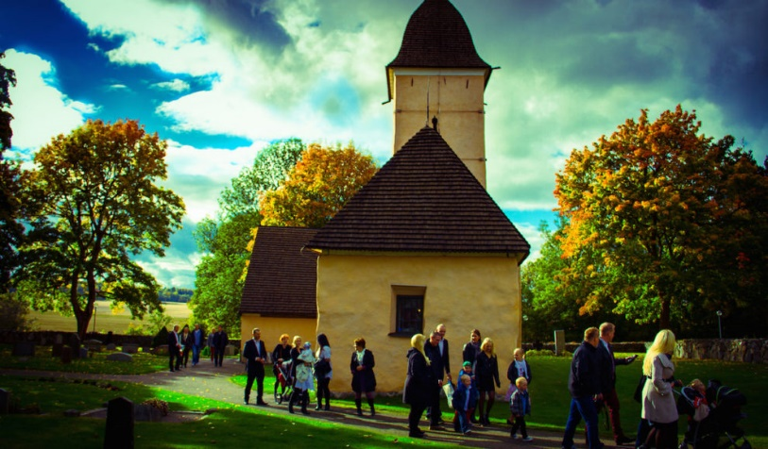
Baptized members- 250*
Communicant members- 215*
Average Sunday attendance- 115
Average % of souls per Sunday- 46%
Average Bible study attendance- 15
Average % of souls in Bible study- 6%
Elementary School attendance- 43
Preschool attendance- 25
Average Sunday School attendance- 8

*Estimated numbers, not yet official in the books.

Month Attendance at each service (Sunday) Total/Average per Sunday
September: 88, 65, 78, 108, 34, 92, 103 568/113
October: 103, 15, 98, 101, 9, 92 418/105
November: 113, 31, 101, 91, 21, 80 437/109
December: 105, 41, 28, 83, 56, 132, 51, 97, 53, 59, 76 781/195
January: 81, 29, 69, 115, 18, 101 413/103

Month Attended 4 or more services** Attended 2 or less services**
September 71 102
October 28 158
November 40 156
December 102 100
January 31 144

**Numbers include children, but not shut-ins, or any of the people who are currently on the deacons’ future release list. Snowbirds are included, but keep in mind that we only have 15-20 of them at St. John’s.

- As you look through these numbers, what strikes you?

- What are some problems you would expect to find at a church where many members do not regularly attend worship and Bible study?

Hebrews 10:19-25

19 Therefore, brothers and sisters, since we have confidence to enter the Most Holy Place by the blood of Jesus, 20 by a new and living way opened for us through the curtain, that is, his body, 21 and since we have a great priest over the house of God, 22 let us draw near to God with a sincere heart and with the full assurance that faith brings, having our hearts sprinkled to cleanse us from a guilty conscience and having our bodies washed with pure water. 23 Let us hold unswervingly to the hope we profess, for he who promised is faithful. 24 And let us consider how we may spur one another on toward love and good deeds, 25 not giving up meeting together, as some are in the habit of doing, but encouraging one another—and all the more as you see the Day approaching.

- What are some reasons it’s so important for Christians to regularly meet together for worship and Bible study?

- Discuss with the people around you. What are some reasons many of our members do not regularly attend worship and Bible study? What, if anything, can we do to get more of our people into the Word?

Acts 2:42-47

42 They devoted themselves to the apostles’ teaching and to fellowship, to the breaking of bread and to prayer. 43 Everyone was filled with awe at the many wonders and signs performed by the apostles. 44 All the believers were together and had everything in common. 45 They sold property and possessions to give to anyone who had need. 46 Every day they continued to meet together in the temple courts. They broke bread in their homes and ate together with glad and sincere hearts, 47 praising God and enjoying the favor of all the people. And the Lord added to their number daily those who were being saved.

- These verses describe what the early Christian church was like. What are some things you notice?

- Verse 47 tells us that “the Lord added to their number daily those who were being saved”, but look at all the things that came before the church’s growth. In what ways do the following behaviors affect a church’s outreach?

  - Devotion to God’s Word, fellowship, the sacraments, and prayer

  - Signs and wonders

  - Charitable help to those in need

  - Daily worship

  - Eating together with glad and sincere hearts

- What are some practical ways we can adjust our personal lives and our church’s ministry to better emulate the early Christian church?

Homework

Complete the sentence with at least three goals.

In order to make the gospel a higher priority in my life and at St. John’s, I want to…

