Church Check-up
#1 Recognize Our Symptoms
Quotations taken from Thom Rainer’s books “Autopsy of a Deceased Church” and “Breakout Churches” for discussion.

Explanation Thom Rainier, two books, and general outline of this eight-week study.
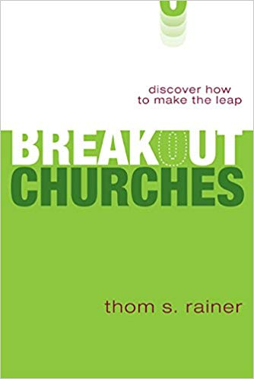
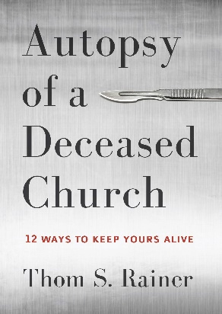

Quote for Discussion

“Jesus told Peter that the Church will never die: ‘And I also say to you that you are Peter, and on this rock I will build My church, and the forces of Hades will not overpower it’ (Matt. 16:18). Indeed the Church will never die. But churches have and are dying. It is my prayer that these autopsies, though painful to watch, will prove helpful to leaders and laity of churches today. As many as 100,000 churches in America are showing signs of decline toward death. May God give us the courage to make the changes necessary to give new life to our churches.” (Autopsy of a Deceased Church p.7)

- Explain the differences between “the Church” and “churches”. What are some reasons it’s important for us as a congregation to keep those differences in mind?

- Agree or Disagree? If a Christian church is faithfully proclaiming the gospel, God won’t let it die.

Romans 6:3-11
³ Or don’t you know that all of us who were baptized into Christ Jesus were baptized into his death? ⁴ We were therefore buried with him through baptism into death in order that, just as Christ was raised from the dead through the glory of the Father, we too may live a new life.
⁵ For if we have been united with him in a death like his, we will certainly also be united with him in a resurrection like his. ⁶ For we know that our old self was crucified with him so that the body ruled by sin might be done away with, that we should no longer be slaves to sin— ⁷ because anyone who has died has been set free from sin.
⁸ Now if we died with Christ, we believe that we will also live with him. ⁹ For we know that since Christ was raised from the dead, he cannot die again; death no longer has mastery over him. ¹⁰ The death he died, he died to sin once for all; but the life he lives, he lives to God.
¹¹ In the same way, count yourselves dead to sin but alive to God in Christ Jesus.
- What are some important truths in these verses we need to keep in mind as we work through this eight-week study?

How healthy is St. John’s?

According to Thom Rainier and his research team, all the churches in the United States can be divided into four categories of health.

Healthy (10%)
- The church’s worship attendance is steadily growing
- The church is actively carrying out the Great Commission and reaching new people with the gospel
- The church is outward-focused and the budget, programs, worship services, etc. reflect that focus
- The members and leaders of the church prioritize worship, Bible study, and prayer
- The church is excited about the future, not dwelling on the past
- The love of Christ is evident in the lives, words, and actions of the church’s members

Symptoms of sickness (40%)
- Decline in worship attendance over the past five years (growing more slowly than the community)
- No clear plan for making disciples
- The church’s focus is moving from an outward focus to an inward focus
- The members and leaders of the church have a lukewarm attitude toward worship, Bible study, and prayer
- Pervasive attitude that the church’s best days are in the past
- The church has a lot of program and ministry busyness, but much of it has no meaningful purpose (primary reason programs and ministries are continued is because “that’s the way we’ve always done it”)

Very sick (40%)
- Significant decline in worship attendance over the past 10-20 years
- The church is not known in the community and new members are rare
- The church’s focus is almost entirely on surviving (keeping the doors open and the lights on)
- The members and leaders of the church mostly just go through the motions of worship, Bible study, and prayer.
- The “good old days” are typically 20 or more years in the past. No one has really felt good about the church in a long time.
- Frustration and conflict within the church significantly limit the joy of the church’s members and leaders

Dying (10%)
- Worship attendance is drastically lower than it was 25 years ago
- Even if the church wants to do outreach, it lacks the manpower and resources to carry it out
- The church’s focus is entirely on surviving. Programs, staff, etc. are regularly being cut or reduced
- Worship, Bible study, and prayer are heavily overshadowed by the stress of trying to stay open
- The “good old days” of the past are long gone, and the future doesn’t look bright
- Overall morale of the church is at an all time low, attitude is mostly grim

- Discuss with the people around you which category you think St. John’s falls into. As you discuss, consider the following information taken from annual synod statistics, current membership records, and Pastor Birsching’s call packet from May 2017.
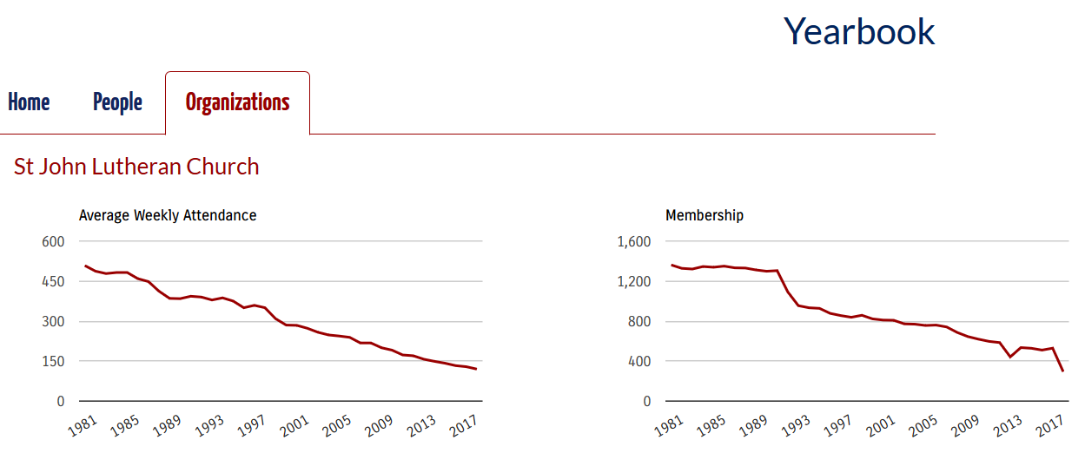

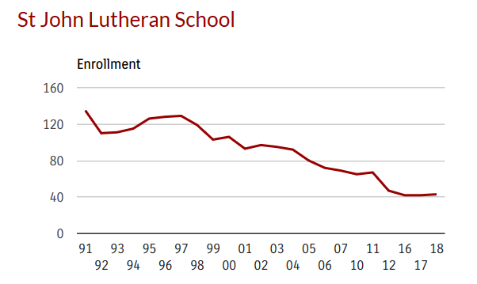
Baptized members- 250*
Communicant members- 215*
Average Sunday attendance- 115
Average % of souls per Sunday- 46%
Average Bible study attendance- 15
Average % of souls in Bible study- 6%
Elementary School attendance- 43
Preschool attendance- 25
Average Sunday School attendance- 8

*Estimated numbers, not yet official in the books.

- The word or phrase that would best describe the current mood/spirit/personality of our congregation is: apathetic, divided, frustrated, sad, stagnant, in need of hospitality and smiling faces, hopeful, at times hiding our light under a bushel, lukewarm
- If I could add or change just one thing to improve my congregation’s service to its Savior and/or its attitude it would be: greater member participation, willingness to open our doors to people of the community and welcome them, unified support of the pastor
- I think we’ve all known for a while that St. John’s is shrinking and that we struggle with unity and outreach. What are some good things that can come from looking at the hard data?

- What are some dangers we need to avoid as we look at the hard data?

Consider

“One of the key reasons many churches today are in a slow but deadly path of erosion is the failure of the people to accept that the church is in trouble and that immediate changes are needed.” (Breakout Churches p. 71)

“Blind erosion, on the other hand, takes place in pseudo-comfort. Most members perceive that no change is taking place, and most of them like it that way. Therein lies the danger. By the time most churches become aware of the years of slow erosion, the damage is severe and sometimes irreversible.” (Breakout Churches p. 174)

“There is no such thing as a plateaued church. A church is either growing or declining. In my research of thousands of churches, I have never seen a church maintain identical statistics for more than two consecutive years.” (Breakout Churches p. 181)

- Discuss with the people around you the following questions:
  - If someone told me that immediate changes needed to be made to my church in order for it to survive, my reaction would be…

  - What are some practical steps we can take at St. John’s to stop slow erosion?

1 Peter 2:9-10

9 But you are a chosen people, a royal priesthood, a holy nation, God’s special possession, that you may declare the praises of him who called you out of darkness into his wonderful light. 10 Once you were not a people, but now you are the people of God; once you had not received mercy, but now you have received mercy.

- What are some encouragements in these verses for our congregation of St. John’s?

Homework

Complete the following sentence with at least one suggestion for each category. I think St. John’s would be a healthier, happier church

if the pastor…

if the teachers…

if the lay leaders…

if the members…

if I…

