Witnessing 101
Case Study on the Apostle Paul before King Agrippa
Acts 26

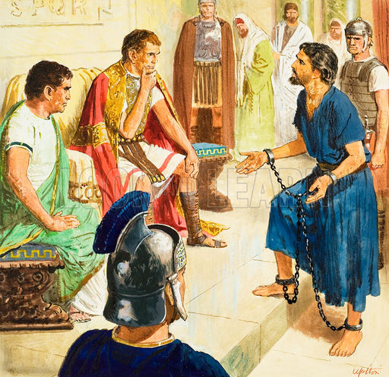
Ponder

Fill in the blank. When I think about the great evangelist Paul I________________________.

Discuss your answers with the people around you.

Read Acts 26:1-11

- Agree or Disagree? The best way to witness to someone is to tell them your story.

- Paul stresses that his Christian beliefs are not opposed to Judaism, but actually are the fulfillment of that religion. What are some advantages and disadvantages of trying to find common ground with people when we’re witnessing?

- In verse 8, Paul brings up the resurrection. In our witnessing, does it make better sense for us to save the resurrection for later after we have shared some easier-to-understand Biblical teachings first? Why or why not?

Read Acts 26:12-18

- What were some reasons Paul’s encounter with Jesus served as such a powerful testimony? In what ways can we take a similar approach in our witnessing?

- Jesus’ words to Paul in verses 16-18 contain both a comfort and a commission. Explain.

Read Acts 26:19-32

- Discuss with the people around you the following questions:

  - What are some good things to do when people respond negatively to our Christian witnessing?

  - What are some good things to do when people respond positively to our Christian witnessing?

- Witnessing will be easy for me if I remember…

