Witnessing 101
Case Study on Jesus and the Samaritan Woman

Discuss with the people around you the following question: What are some reasons witnessing to others about Jesus is often a hard thing for us to do?

Read John 4:4-10

- Reasons Jews didn’t like Samaritans:
  - They were a mixed race (leftover Jews from the Northern Kingdom who had intermarried with the other people the Assyrians had settled in Israel)
  - They practiced a mixed religion (elements of Judaism and paganism combined)
  - They worshipped on a different mountain other than the temple mount in Jerusalem.

- What are some surprising things in these verses?
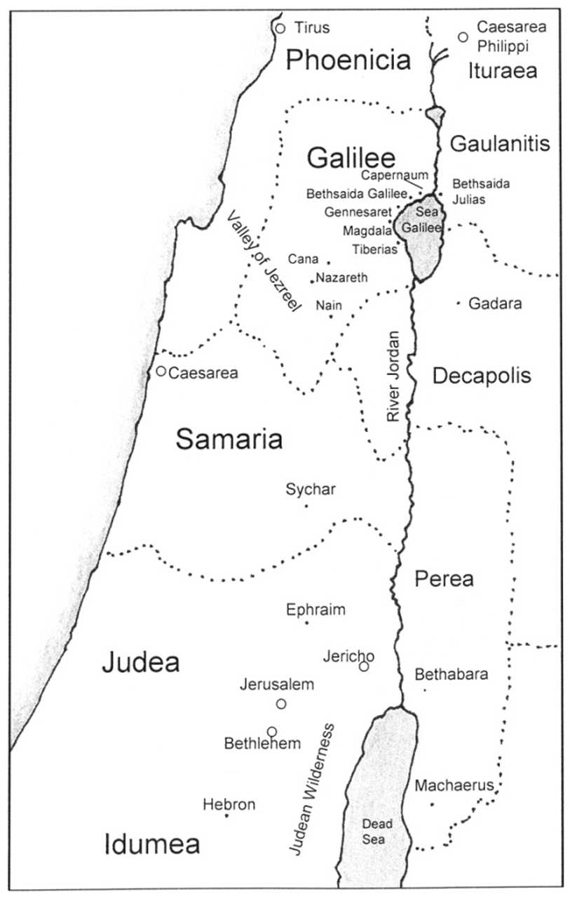

Read John 4:11-18

- Comment on Jesus’ approach to witnessing. What are some things we can learn from it?

- Agree or Disagree? When we witness, we should start talking about Jesus right away.

- Respond. We shouldn't point out people's sins when we witness to them because it might cause them to end the conversation.

Read John 4:19-26
- Agree or Disagree: When we’re witnessing, we shouldn't spend too much time answering people’s questions because they distract from the gospel message we’re trying to communicate.

- Obviously, we can’t see into people’s hearts or claim to be God’s promised Messiah. What are some reasons we can still witness to people boldly?

Read John 4:27-42

- Discuss the following questions with the people around you.
  - What are at least five things these verses teach us about witnessing?

  - What are some ways we can open our eyes and better see the “harvest fields” around us?

- My biggest take-away from this case study on witnessing is…

