After God’s Own Heart
Lesson 5: A Repentant Heart

I’m Sorry!

Discuss with the people around you some reasons why apologies are so important for healthy relationships.

Read 2 Samuel 11:1-17

In these verses, we see a progression of sin taking place. As Pastor reads these verses, try to track David’s various mistakes.

Instead of leading Israel’s army David _________________________________________________________
When David saw a woman bathing he _________________________________________________________
After David learned she was married he ________________________________________________________
When David learned she was pregnant he ______________________________________________________
When Uriah didn’t go home, David ____________________________________________________________
When Uriah still didn’t go home, David ________________________________________________________

- In our other studies, we saw that David was a man after God’s own heart. In what ways did sin distort David’s…

Humble heart?

Passionate heart?

Loving heart?

Thankful heart?

- What are some lessons we should take from this account about guarding our hearts from temptation and sin?

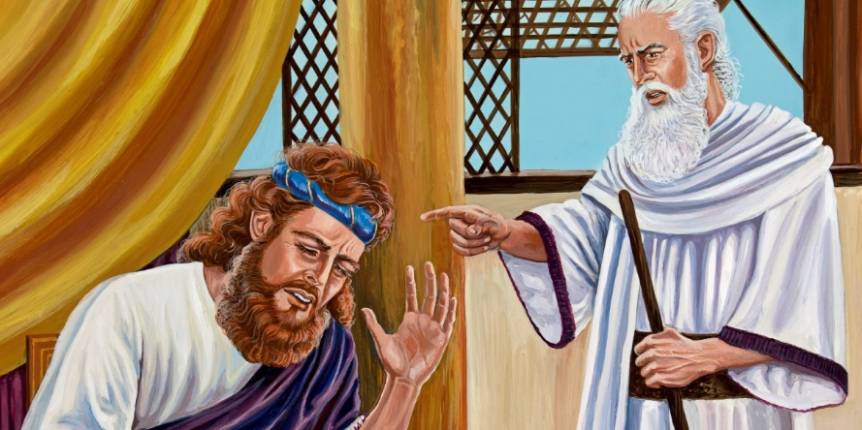
Summary of 2 Samuel 11:18-27

Joab followed David’s orders and Uriah was killed in battle. After Bathsheba grieved for her husband, David married her and she gave birth to a son. From a human perspective, everything worked out great for David, but the thing he had done displeased the LORD.

Read 2 Samuel 12:1-14

- After almost a year of living in sin, David’s heart is once again turned back to God. What are some things we learn about repentance from these verses? Discuss with the people around you.

- Agree or Disagree? The key to becoming a better Christian is to do more repenting.

Read 2 Samuel 12:15-25

- What are some indications in these verses that David is back to being “after God’s own heart”?

- What are some spiritual and earthly blessings that can come when we repent of our sins?
