After God’s Own Heart
Lesson 2: A Passionate Heart
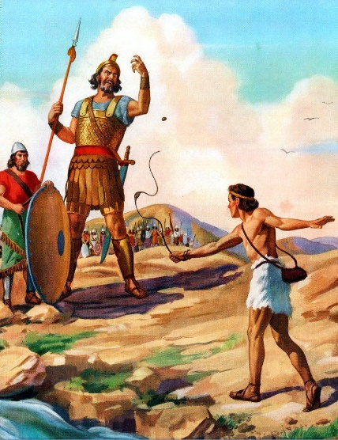
Warming Up

Even today in our secular world, the story of David and Goliath is still well-known and eluded to often. Discuss with the people around you some possible reasons for that?

Read 1 Samuel 17:1-11

Goliath’s height – about 9 feet and 9 inches Spear shaft – about 8-9 feet tall, 2 ½ inches thick
Armor weight – about 125 pounds Spear head – about 15 pounds

- What are some problems you identify in these verses?

- In our lives, we probably aren’t being threatened by too many 10-foot-tall soldiers. What are some other dangers or enemies we face that challenge our passion for God?

Summary of 1 Samuel 17:12-22

Jesse sends his youngest son David to go check on his three oldest brothers who are serving in the Israelite army with King Saul. While David is talking with his brothers, Goliath comes out and gives the same challenging spiel he had been giving for 40 days straight.

Read 1 Samuel 17:23-31

- Contrast David’s reaction to Goliath’s words with the reaction of the rest of the Israelites. What are some things you notice?

- David’s oldest brother Eliab was furious with David for talking with the men about Goliath. What are some possible reasons for his anger?

- It seems a little strange that David kept asking the same questions over and over again to different soldiers. What might have been some things David was trying to accomplish with his repeated questioning?

Read 1 Samuel 17:32-40

- What are some things you like about David’s attitude and approach to fighting Goliath?

- Agree or Disagree? One of the best ways to be passionate for God is to remember our past accomplishments.

Read 1 Samuel 17:41-53

- With the people around you, discuss the following questions:

  - Someone whose heart is passionate for God will __________________________________.

  - When I’m struggling to be passionate for God it’s usually when ______________________.

- Which of the following areas of your life could benefit the most if your heart was filled with more faith-based passion? Why?

Your work Your friends Your gospel witnessing
Your devotional life Your marriage Your church involvement
Your finances Your children Your community involvement
Your health Your extended relatives Other?

