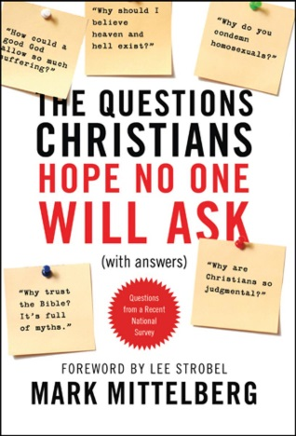
10 Questions Christians Hope No One Will Ask

Question 3: Why trust the Bible, a book based on myths and full of contradictions and mistakes?

Look over the following list of objections people often have about the Bible and then discuss them with the people sitting nearby. Which objections are easiest for you to answer? Which ones would be the hardest for you to answer? What other objections have you heard from people?

- The Bible is very old and was written by gullible, illiterate people; therefore, we can’t trust it.

- The Bible was written too far after the events actually happened to be considered reliable.

- Even if it was accurate at first, the Bible was copied and translated so many times that is surely has been corrupted.

- The Bible has stories that sound like myths; maybe there is truth in there somewhere, like in Aesop’s fables, but you certainly can’t call it true in a historic sense.

- The New Testament consists of carefully chosen books, banning others that shed light on the real Jesus of history.

- How can one religious book be right and all the others wrong? Isn’t it more likely all contain some truth, and all contain some error?

- Since ancient mystery religions taught tales of dying and rising gods, isn’t it likely Christians borrowed those ideas and invented a Jesus who claimed to do similar things?

- Since you can make the Bible say anything you want it to say, why should we give it any special credence? Doesn’t it all come down to subjective opinion, anyway?

- What are some reasons people are so eager to discredit the Bible?

- In what ways do the following historical facts support the Bible’s reliability?

- Far more ancient manuscripts exist of the books of the Bible than any other piece of literature.
- The ancient manuscripts come from all over the world, not just one small area.
- The ancient manuscripts were carefully copied and preserved by professional scribes.
- 99% of the variants in the thousands of manuscripts are not major variants (misspelled words, duplicated words, verb tenses, etc.)
- Of the 1% of variants that are major variants, none of them affect any doctrines of Scripture.
- When Jesus was on earth, he frequently quoted the Old Testament and never once identified any problems with it or suggested any revisions.
- In the case of the New Testament, several of the manuscripts date back to only a few years after Jesus’ earthly ministry.

Read Matthew 24:35 and Luke 21:33

- What are some reasons Christians can trust this promise from Jesus?

Read 2 Peter 1:20-21

- How might these verses be helpful when you talk to people about the Bible?

- Since the Bible is God’s Word and therefore without error, how do we explain alleged contradictions like the following?

What was really written on the cross above Jesus’ head?
Matthew 27:37 says, “This is Jesus, the King of the Jews.”
Mark 15:26 says, “The King of the Jews.”
Luke 23:38 says, “This is the King of the Jews.”
John 19:19 says, “Jesus of Nazareth, the King of the Jews.”

How many angels were at Jesus’ tomb after the resurrection?
Matthew 28:2 mentions one angel
Mark 16:5 says there was “a young man” in the tomb
Luke 24:4 mentions two men clothed in dazzling robes.

How did Judas die?
Matthew 27:5 says he went out and hanged himself.
Acts 1:18 tells us he fell, and “his body split open, spilling out all his intestines.”

Read 2 Timothy 3:16-17

- Explain. Trying to convince people of the verbal inspiration of the Bible is sort of like putting the cart before the horse or like trying to defend a caged-up lion.

- What do you think about the following suggestions by Mittelberg?

On a practical level, before trying to answer every concern that people might conceivably raise about the Bible, I believe we’re wise to call their bluff by asking them to be specific. You can do that with a question of your own: “You say the Bible is full of mistakes and contradictions. I’m curious: Which ones bother you the most? What mistakes and contradictions have you found?” (p. 70)

Another approach is to suggest that questioners start reading one book of the bible, say the Gospel of Mark or the Gospel of Luke, in a modern translation. Tell them to have a notepad handy. As questions arise, they can jot them down, along with the verse numbers. Commit to them that you’ll get together when they are done, and agree to go over whatever they write down so you can help them work through whatever doesn’t make sense. (p. 96)

“It ain’t those parts of the Bible that I can’t understand that bother me, it is the parts that I do understand.” – Mark Twain (quoted by Mittelberg on page 70)

