After God’s Own Heart
Lesson 4: A Thankful Heart

Count Your Blessings

Spend three minutes writing down as many specific blessings as you can. When time is up, go through your list and circle the blessings you have thanked God for today. Be ready to discuss your list with the rest of the group.

Summary of 2 Samuel 6:1-11

The first time King David tried to bring the ark of God to Jerusalem, it didn’t go well. He learned from his mistakes though and God allowed David’s second attempt at bringing up the ark to be successful.

Read 2 Samuel 6:12-19

- At this point in his life, David was thankful to God for a great many things. What were some blessings God had given to him?

- In what ways did David show his thankfulness to God?

- We probably don’t have the means to put on a public celebration of thankfulness quite like David did. What are some feasible ways we can display our thankfulness to God publicly?

Read 2 Samuel 6:20-23

- Explain. In order to show true thankfulness, we need to humiliate ourselves.

- A lot of people may not understand, or may even make fun of Christians like us when we are expressing our thankfulness to God. Discuss with the people around you some ways you can respond in those situations.

Summary of 2 Samuel 7:1-17

David wanted to show his thankfulness to God by building a glorious house for the ark. Instead, God told David that he was going to build a “house” for him by preserving his royal line forever.

- Agree or Disagree? When we give thanks to God, he will give us even more blessings.

Discuss 2 Samuel 7:18-29

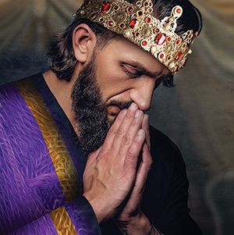
- What are some things we see in David’s prayer that would be good to include in our own prayers of thanksgiving?

- Fill in the blank. Since my heart is filled with thankfulness to God I will _____________________.

