After God’s Own Heart
Lesson 3: A Loving Heart

Warming Up

In our sinful world, love can be a hard thing to find, but because God is still active in this world through his Word and his people, love does still exist. Discuss with the people around you some examples of love you’ve seen or heard about.

Read 1 Samuel 24:1-7

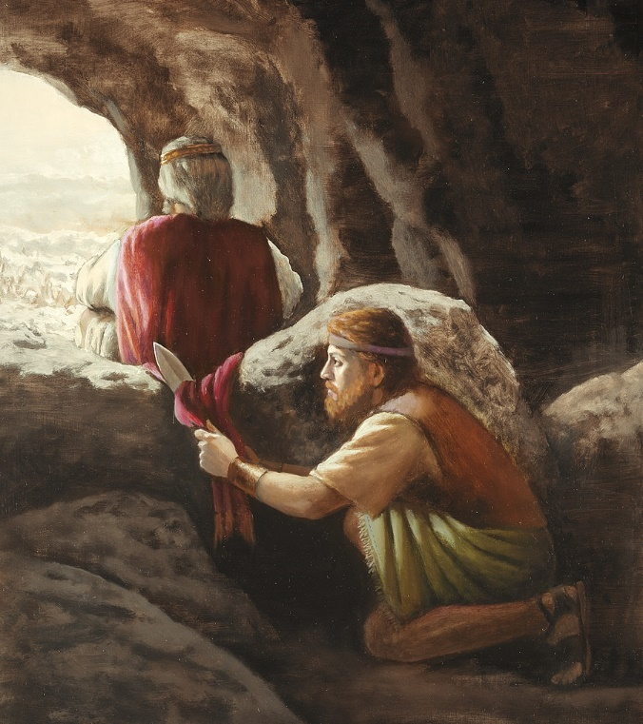
- What were some reasons King Saul was pursuing David with an army?

- They didn’t have portapotties in ancient Israel. So when King Saul needed to relieve himself, he went into a nearby cave, which happened to be the very cave in which David and his men were hiding! What were some reasons David might have wanted to kill Saul at that point?

- We probably haven’t ever had someone chasing after us with an army to kill us. But we’ve all been hurt by people before. What are some common ways we are tempted to take revenge? Discuss with the people around you.

Read 1 Samuel 24:8-15

- What are some reasons David spared Saul’s life?

- What are some ways people show a lack of love and respect for “God’s anointed” government officials today? What are some ways we can try to stem the tide?

- Discuss the following scenario with the people around you. One of your close relatives hurt you badly. They said some very unkind things to you and talked badly about you to the rest of the family. You’ve tried to talk with this relative in the past about how they hurt you, but they have never apologized or taken back any of their hurtful comments. Recently though, this relative has fallen on hard times. They come to you asking for money and a place to stay. What are some ways you can show Christian love to this person? What are some truths you might have to remind yourself of in order to show that kind of love?

Read 1 Samuel 24:16-22

- Agree or Disagree? If we show love to other people, they will love us back.

Apply

- Discuss with the people around you the following questions:

- What are some big obstacles we face when it comes to showing love to other people?

- What are some good results that can happen when we do show love to other people?

