After God’s Own Heart
Lesson 1: A Humble Heart

Warming Up

What are some things you remember about David? Discuss that question with the people around you and try to come up with a list of as many facts about David as possible.

Read 1 Samuel 13:5-14

We can’t truly understand David without comparing him to his predecessor Saul. In some ways, Saul was a good king for Israel, but Saul was never described as “a man after God’s own heart”. In sections of Scripture like this one, we see why.

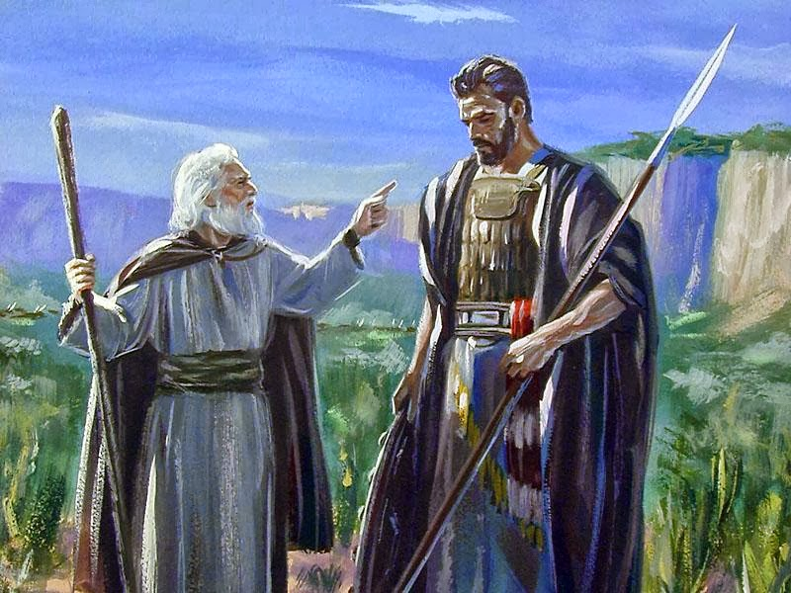
- In your own words, describe what took place in these verses.

- What are some things we learn about Saul from his actions here?

- From what we’ve seen so far, what are some important qualities of being “after God’s own heart”?

Summary of 1 Samuel 15:1-11

Here again, we see only partial obedience on Saul’s part. The next verses show very clearly that Saul was not a man after God’s own heart. As Pastor reads the verses, try to write down at least five things that Saul did wrong.

- 4.

- 5.

Read 1 Samuel 15:12-31
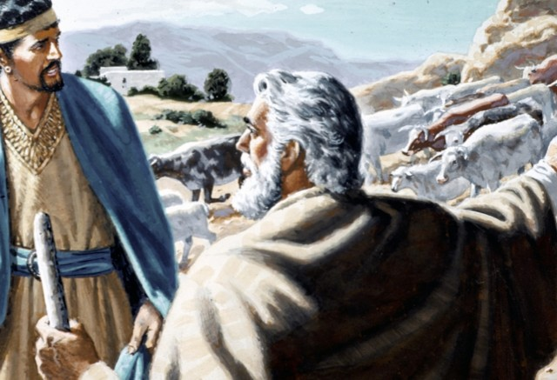
- With your list of Saul’s mistakes in front of you, discuss the following questions with the people around you.

  - Which of Saul’s sins in these verses do you think was the most serious? Why?

  - Which of Saul’s sins in these verses do you personally struggle with the most? Explain.

Read 1 Samuel 16:1-13

- God made it clear to Samuel that he didn’t choose David to be the next king because of his outward appearance, but because of his heart (v 7). Though David’s heart is not specifically described for us in these verses, we have a pretty good idea of what God liked about David if we think about what God didn’t like about Saul. If we could see David’s heart through God’s eyes, what would be some good characteristics or qualities we would see?

- God has not anointed any of us to be king over the United States, but he still has called us to be people after his own heart. In your daily life, what are some ways you strive to align your heart and life with God’s will?

- Explain. Nothing changes our hearts better than looking into God’s heart.

