Busy Believers

Which of the following pictures best describes the busyness of your life?

1. 2.

3. 4.

Which of the pictures would you like your life to be more like? Why?

Busyness is part of this world. It affects everyone and believers are no exception. In fact, believers have extra busyness because they have responsibilities to God in addition to everything else they have to do. The Bible never promises that believers lives will be free from busyness, but it does give guidance on how to manage our busyness in a way that honors God.

Part 1: Is busyness bad?

Genesis 2:15 (2)

- What does this passage make clear about work?

Genesis 3:17-19 (3-4)

- What did sin change about work?

Proverbs 10:4-5 (633), Proverbs 12:11 (636), Ecclesiastes 10:18 (666)

- What are some obvious consequences for not working?

Ecclesiastes 11:6 (666)

- How does uncertainty affect the amount of time we spend working?

- Agree or Disagree? A Christian doesn’t need to “hedge his bets”.

Ecclesiastes 9:10 (665)

- What insights does this passage add about working?

John 9:4 (1061)

- What work does Jesus make clear needs to be part of every Christian’s life? Why?

Ecclesiastes 5:18-20 (662)

- Why can believers find enjoyment in work?

2 Samuel 11:1-5 (304-305)

- What can happen to believers if they don’t keep busy?
Case Study 1: Paul the Tentmaker
Acts 18:1-4 (1098)
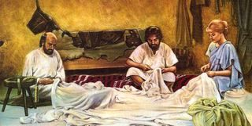

While the Apostle Paul sometimes received gifts from Christian congregations to do his mission work, he often supported himself by making tents. Paul did this for several reasons. He did not want anyone to accuse him of “peddling the gospel” for money. Paul also did not want to be a burden on the people to whom he ministered. A third reason Paul supported himself, was to set a good example for other Christians. He expands on that thought in 2 Thessalonians 3:6-13 (1173).

- What is Paul’s opinion of idle believers?

- What is the difference between being a busy person and a busybody?

- Why did Paul command and urge the idle believers “in the Lord Jesus Christ”?

- How is it possible for believers to “never tire of doing what is right”?

13. Busyness is not bad because…

Part 2: Beware of busyness!

Name some of the good things you see in this picture. Now name one really big problem?

We reviewed in Part 1 that work is not evil; it is a blessing from God. Likewise, busyness itself is not bad, in fact, it can be a good thing. Like anything else though, too much of a good thing is dangerous. Today we will look at the warnings God gives us about being too busy.

Proverbs 23:4-5 (648)

- What are two problems with trying to get rich?

Ecclesiastes 2:17-23 (659)

- Why does Solomon describe hard work as “meaningless”?

- Isn’t it a good thing when parents leave behind lots of good things for their children?

- Evaluate: “The one who dies with the most toys wins.”

Matthew 16:26 (973)

- What is easy to neglect when we are busy? Why is that?

Haggai 1:3-11 (937)

- The Israelites were indeed busy when they returned from exile. What was the problem with their busyness? What were the consequences?

- Agree or Disagree? If your busyness is not resulting in blessings, it’s probably because you have been neglecting God.

Ephesians 5:33-6:4 (1159-1160)

- What else is often put on the back burner when we are busy?

- How is busyness a danger to:

Spouses?

Parents?

Children?

The family unit?

- Why should we sacrifice busyness for family instead of family for busyness? How can we get better at doing this? What if family causes most of our busyness?

Case Study 2: Mary and Martha
Luke 10:38-42 (1028-1029)

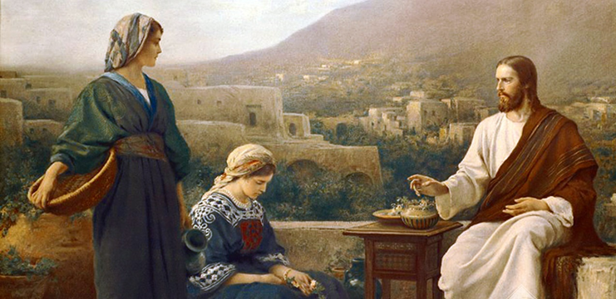

When Jesus was working in and around Jerusalem, he would often stay in the village of Bethany with Martha and her sister Mary (sisters of Lazarus). The two sisters reacted very differently the first time Jesus stayed with them.

- What were each of the two sisters concerned about?

- Was it wrong for Martha to be taking good care of her guests? What was the problem?

- What are some ways we can be more like Mary in our Martha world?

14. I need to beware of busyness because…

Part 3: Balance for Busyness
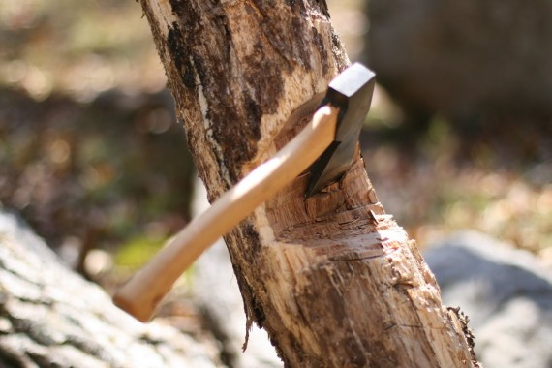
Once upon a time, a very strong woodcutter asked for a job in a timber merchant and he got it. The pay was really good and so was the work condition. For those reasons, the woodcutter was determined to do his best.
His boss gave him an axe and showed him the area where he supposed to work. The first day, the woodcutter brought 18 trees. “Congratulations,” the boss said. “Go on that way!”
Very motivated by the boss words, the woodcutter tried harder the next day, but he could only bring 15 trees. The third day he tried even harder, but he could only bring 10 trees. Day after day he was bringing less and less trees.
“I must be losing my strength”, the woodcutter thought. He went to the boss and apologized, saying that he could not understand what was going on. “When was the last time you sharpened your axe?” the boss asked. “Sharpen? I had no time to sharpen my axe. I have been very busy trying to cut trees…”

This woodcutter’s silly mistake shows us that being busy is not the same as being productive. In today’s fast-paced world, it is not hard for believers to keep busy. God’s Word makes it clear though that busyness needs to be balanced or we will end up just like the woodcutter, frustrated and tired with nothing to show for our labors.

Ecclesiastes 10:10 (665)

- This would have been a great passage for our woodcutter friend to read. How does it apply to us non-woodcutters?

Proverbs 19:2 (643)

- What two things is this passage advising? How do we obtain them?

2 Timothy 3:16-17 (1179)

- What is the best thing a believer can do to be prepared for life’s busyness? In what ways has it helped you?

- What are some practical steps you can take, or have taken, to make God’s Word a priority in your life?

Mark 6:30-31 (996), Luke 5:16 (1019)

- What did Jesus understand about busyness?

- Why is prayer helpful?

Philippians 2:4 (1162)

- Explain: A Christian who spends all day reading the Bible is like a doctor who never leaves medical school.

Proverbs 27:17 (653)

- In what ways does the world dull us? How do believers “sharpen” one another?

Case Study 3: Moses and Jethro
Exodus 18:13-23 (72)

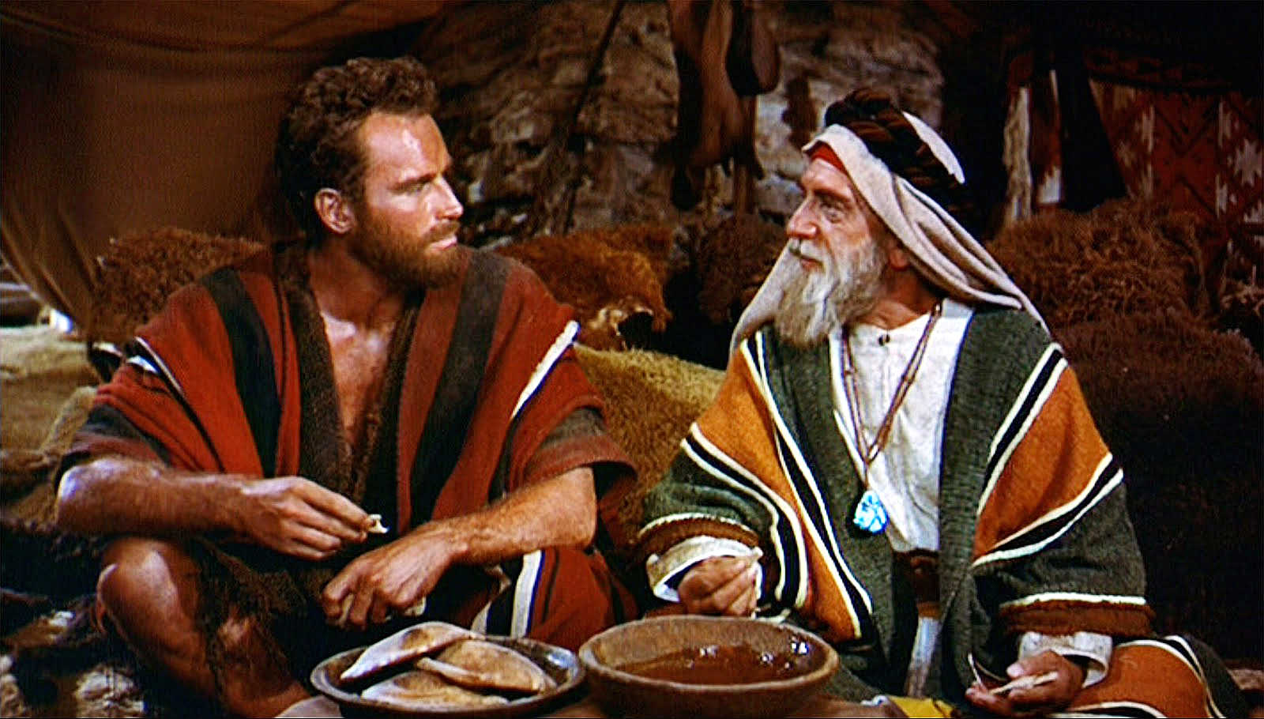

God had delivered the Israelites from slavery in Egypt, but the nation still had plenty of challenges ahead of it. Some of the greatest challenges would be faced by Moses their leader. In this account, God used Moses’ father-in-law Jethro to teach him a valuable lesson about leadership and busyness.

- What was the problem? What did Jethro predict would happen if it wasn’t fixed?

- What was the solution? How can we follow Jethro’s advice in our busy lives?

Acts 26:17-18 (1108)

- Believers shouldn’t only busy themselves with other believers. Who else needs our time? Why is their need so urgent?

1 Peter 4:10-11 (1203)

- Explain: Not every believer is a missionary, but every believer is a missionary.

Colossians 3:23-24 (1167)

- How hard should we work? Why?

- Agree or Disagree? Christians should work hard because they want God to reward them.

1 John 2:15-17 (1208)

- How do these verses put busyness in perspective?

1 Timothy 3:5 (1175)

- Volunteering in the church is one of many ways believers can be busy for the Lord. What reminder does God give to those wanting to serve in this way? What does this tell us about how we should prioritize our busyness?

Matthew 11:28-30 (966)

- When we are worn out by busyness, where must we turn? How do we do that?

- What is the yoke and burden Jesus places on us? Why is it easy and light?

19. The best way to balance busyness is…

Isaiah 40:28-31 (715)

Do you not know?
Have you not heard?
The LORD is the everlasting God,
the Creator of the ends of the earth.
He will not grow tired or weary
and his understanding no one can fathom.

He gives strength to the weary
and increases the power of the weak.

Even youths grow tired and weary,
and young men stumble and fall;

But those who hope in the LORD
will renew their strength.
They will soar on wings like eagles;
They will run and not grow weary,
they will walk and not be faint.

“When a storm is coming, all other birds seek shelter. The eagle alone, avoids the storm by flying above it. So in the storms of life… may your heart soar like an eagle.”

