Lesson 4: The Freedom of Worship

What do you know about the history of worship in the Bible? Discuss with the people around you what worship was like during the following time periods. Feel free to glance through the Bible passages if you need to jog your memory a bit.

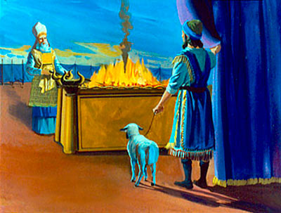
Worship in the time of the patriarchs (before God gave his law at Mount Sinai). [Genesis 4:26, 8:20, 12:6-8]

Worship in the time of the tabernacle and temple (after God gave his law at Mount Sinai). [Leviticus 1:3-9, 1 Kings 8:62-66]

Worship in the time of the New Testament church (after Jesus ascended back into heaven). [Acts 2:42-47]

Read Colossians 2:16-17

- Since “the reality is found in Christ”, what is the only thing that has to be part of our worship today?

- Agree or Disagree? Since Jesus fulfilled all the Old Testament laws about worship, we don’t need to pay attention to them anymore.

- Explain. New Testament Christians do not have rules when it comes to worship, but we do have principles.

Read 1 Corinthians 10:23-33

- What are some worship principles in these verses?

- Agree or Disagree? Since Christians should seek the good of others, we shouldn’t make a big deal about our own opinions regarding worship.

Read 1 Corinthians 12:12-26

- What are some worship principles in these verses?

- Discuss with the people sitting around you the following question. A congregation that wants to have unity needs to ______________________________ .

- What are some practical ways a church can make use of its members’ varied gifts in worship services?

Read 1 Corinthians 14:1-5

- What are some worship principles in these verses?

- It is doubtful that St. John’s will ever include tongue-speaking in its worship services. What are some other possible ways we could hinder edification in worship?

Read 1 Corinthians 14:26-40

- What are some worship principles in these verses?

- Respond to the following criticism: “You Lutherans continue to oppress women by forcing them to submit to men! What do you have against freedom?”

- Discuss with the people around you the following questions. What are some things we do at St. John’s to maintain order in our worship services? What are some possible ways we could improve order in our worship services?

Apply

- Of all the Biblical worship principles we’ve discussed, which principle is most difficult for you to follow? Why?

- Agree or Disagree? Since the pastor knows the most about worship and the Biblical principles of worship, he should be the one to make the decisions about the congregation’s services.

- When a congregation remembers the freedom God has given them in worship, in what ways will they benefit?

