Lesson 2: The Purpose of Worship

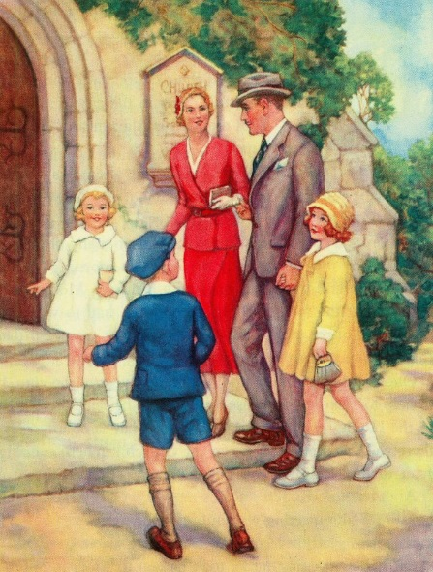
Discuss with the people sitting around you the first time, or first few times, you attended a St. John’s worship service. What were your impressions? What stood out to you about the service? If you can’t remember your first time in a St. John’s worship service because you were a child at the time, imagine yourself in a visitor’s shoes. What would be the first things you noticed when you walked into our church? What would you be looking for in the service?

Read Leviticus 16:6-22

- If you were a young Israelite child watching the priests perform their duties on the Day of Atonement, what would be some things you would notice?

- What rituals do we have, if any, in our worship services today that impress the truths of God’s Word in a memorable way?

- What are some possible reasons for why God required more elaborate and graphic rituals for Old Testament worship than he does for New Testament worship?

Read Acts 2:42-47

- What were some memorable or impactful things which were present in the early New Testament worship services?

- Agree or Disagree? If we want St. John’s to thrive and grow, we should do the same things the early New Testament believers did.

Read Leviticus 19:30 and 2 Samuel 6:14-16, 20-23

- Discuss with the people around you the following question. What is the balance between being reverent and being joyful in a worship service? (In other words, where should St. John’s fall between the shouting and clapping of the Baptists and the incense burning and chanting of the Greek Orthodox?
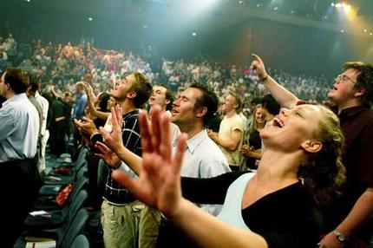

Apply

- Agree or Disagree? The more beautifully decorated a church is, the more impactful its proclamation of the gospel will be to those who worship there.

- Even though variety is important, what are some benefits to making our services repetitive and predictable? (e.g. Saying the Lord’s Prayer every week)

- Discuss with the people around you the following question. Is it more important for a worship service to proclaim the gospel in a way the congregation likes or in a way that is attractive to visitors?

- On the provided index card, write three things you really like about St. John’s worship services. Then write three possible changes we could make as a congregation to make our worship services even better. You can put your name on the card if you wish, but do not have to do so. Once you are done, hand in your card to pastor.

