Biblical Principles of Christian Worship
With specific applications to St. John’s Lutheran Church in Westland, Michigan.

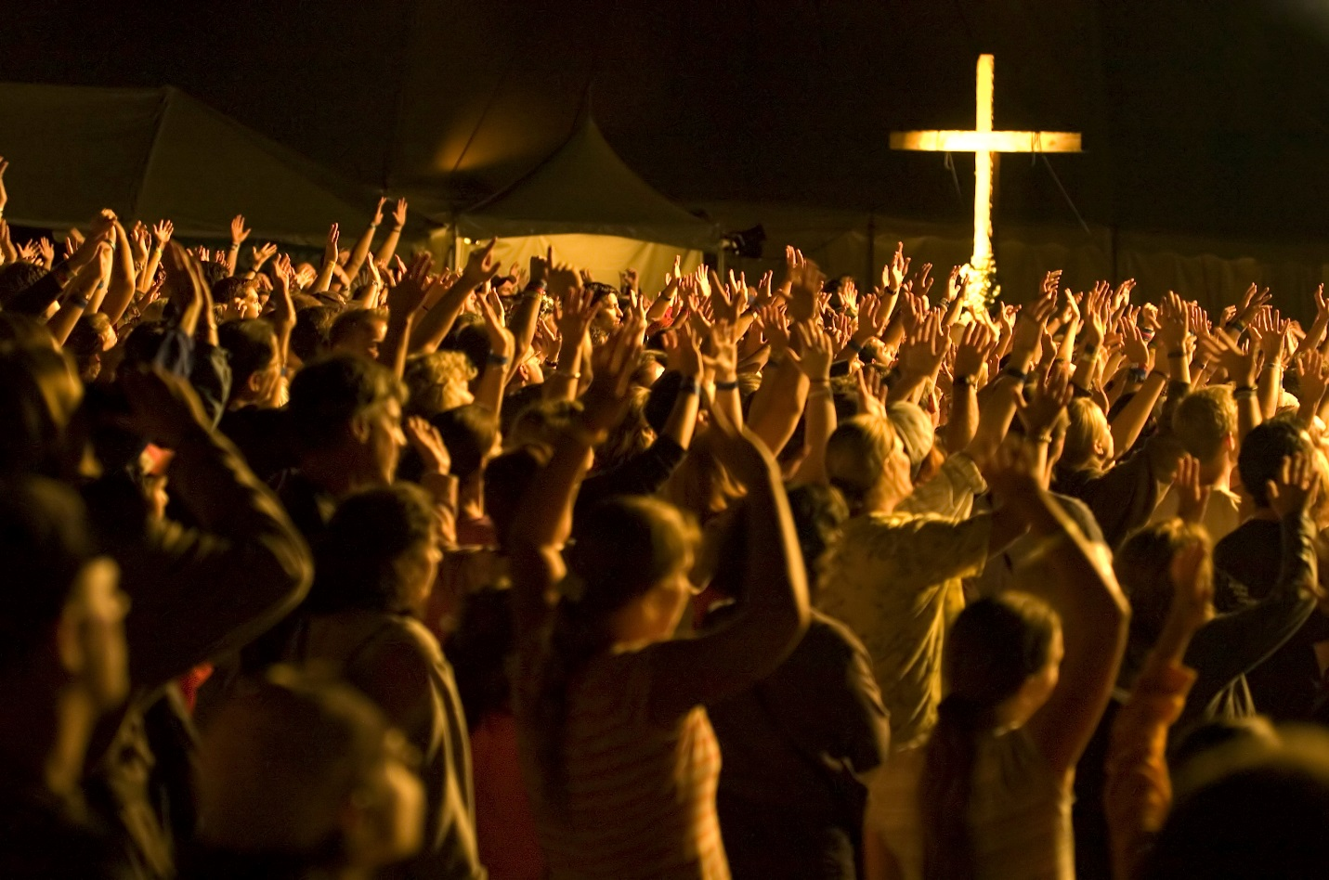

Lesson 1: The Definition of Worship

What does it mean to “worship”? Discuss with the people sitting near you and come up with a simple definition. Feel free to ask Google or Siri if you need help.

Read Matthew 22:37

- What does it look like to “love the Lord with all our hearts, souls, and minds”?

Read 1 Corinthians 12:3

- Explain. Worship is not just something we do for God.

Read Psalm 50:7-15

- If God doesn’t need our worship, why does he ask for it?

Read Romans 12:1-2

- Your friend asks you: “When do you worship God?” Should you answer by telling them St. John’s service times? Why or why not?

Read Psalm 119:11 and John 8:31

- What are some reasons God’s Word is the most important part of Christian worship?

Read Hebrews 10:25

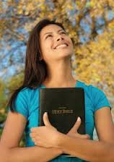
- Discuss with the people around you the following scenario. You’ve noticed that a long-time member of St. John’s hasn’t come to a worship service in several months. When you visit their house to check up on them, they give you this response: “I appreciate your concern, but I don’t need to go to church. I read my Bible every day and pray to God regularly. I’m able to worship God just fine on my own.” What are some points you should make to this Christian?

- Your unbelieving friend says to you: “If church is so important, why do you Christians make it so hard to attend? The services are always super boring and are usually scheduled for Sunday mornings when people like me are trying to sleep in.” How would you respond to your friend?

Apply

- Explain. Worship is not so much about praising God as it is about proclaiming his gospel to his people.

- Agree or Disagree? Since worship at St. John’s always proclaims God’s Word faithfully, our services don’t need to be emotionally exciting.

- Imagine you and the people sitting near you are part of the St. John’s Worship Team and are responsible for choosing the songs we use in our worship services. Discuss whether you will select traditional hymns from the hymnal, contemporary Christian songs, or some of both. What will your criteria be for deciding which songs to use?

