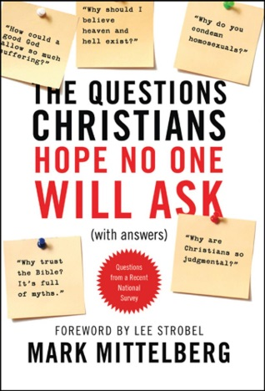
10 Questions Christians Hope No One Will Ask

Questions 8-9: How can I trust Christianity when so many Christians are hypocrites and judgmental toward everyone else?

What are some examples of Christians being hypocritical or judgmental. Why do these behaviors bother people so much?

Read Matthew 23:1-12, Matthew 23:13-22, Matthew 23:23-32

- Discuss you assigned passages with your group and answer these questions. What were some examples of the Pharisees’ hypocrisy which Jesus condemned? Do Christians still struggle with these sins of hypocrisy today? If so, what does it look like?

- What are some reasons Jesus was so harsh in his condemnation of hypocrisy?

- Why might this section of Scripture be a good place to take someone who is upset about Christians’ hypocrisy?

Read Hebrews 4:15, Matthew 26:59-60, and John 8:46

“Ultimately we need to encourage our friends to put their faith not in Christianity—and certainly not in the flawed efforts of frail Christians—but in the powerful and proven person of Jesus Christ himself.” (p. 231)

- Agree or Disagree? When people get upset about the sins of Christians, we just need to redirect their attention to the sinlessness of Jesus.

Read Titus 1:15-16 and Jude 1:3-4

- What do these passages add to the discussion of hypocrisy among Christians?

- What are some reasons Christians should not appoint themselves to be “hypocrite hunters” in the church?

Read Romans 7:14-25

- Discuss with the people around you the following question: What are some ways we can use the doctrine of the two natures of Christians in our witnessing?

- React to the following statement. If we want to reach the hearts of other people, first we need to show them the ugliness in ours.

Read Matthew 7:1-5, Matthew 18:15-17, and John 7:24

- Are Christians supposed to judge others or not?

- What are some dangers Christians face when we judge others? What are some problems that will occur if we don’t judge others?

Read John 4:16-20

- When people accuse Christians of being hypocrites or judgmental, what might they be trying to do? How should we handle such accusations?

“We’re not smarter than others, we’re not better than they are, and we’re not more worthy than anyone else—we’re just blessed to have found what we have in Christ and are privileged to get to share it with them.” (Mittelberg p. 240)

