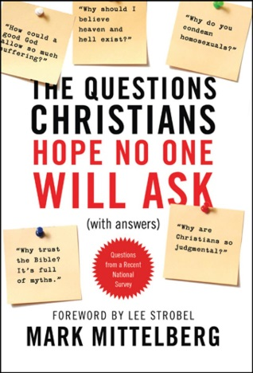
10 Questions Christians Hope No One Will Ask

Question 7: Why do you condemn homosexuality when it’s clear that God made gays and that he loves all people the same?

“You Christians are all the same! You talk about God’s love, but then look down your noses at anyone who’s different from you! You have no right to judge me for being gay! I was born this way and God loves me just the way I am!” Discuss with the people nearby some ways you would answer this accusation.

Read 1 Timothy 2:3-4

- What insights do these verses offer into the kind of love God has for homosexuals?

- Agree or Disagree. We as Christians should make it clear to the world that we love homosexuals and want to be around them.

Read Genesis 2:20-24

- What are some reasons these verses are a good place to start when talking with someone about homosexuality? (Keep in mind that Jesus and Paul also quoted these verses in Matthew 19:3-8 and Ephesians 5:31)

Read Leviticus 18:22 and Leviticus 20:13

- What are some problems with using these verses to condemn homosexuality?

- What, at the very least, do these verses show?

Read Genesis 19:1-5, 23-25

- In what way does this account portray homosexuality?

- “But that was a different type of homosexuality! Those wicked men were trying to force themselves on unwilling participants. The kind of homosexuality that takes place in modern times is between two loving partners who give mutual consent.” Respond.

Read Romans 1:24-27, 1 Corinthians 6:9-11, and 1 Timothy 1:8-11

- Discuss with your group your assigned section of Scripture and answer this question: What do these verses make clear about homosexuality?

- There have been numerous scientific studies done to try and determine if certain people are more inclined toward homosexuality because of genetics, upbringing, etc. Thus far, the studies have been inconclusive, but it is possible that a future study will indeed prove that some people are especially susceptible to homosexual temptations (a.k.a. “born gay”). What are some reasons such a study would not change our stance on homosexuality?

Read John 8:2-11

- Even though this account is not referring to a homosexual, what are some things we can learn from Jesus about how to treat people who are struggling with homosexuality?

- Discuss with the people around you the following scenario. Your 18-year-old son comes to you and tells you that he is gay. As a loving Christian parent who understands what the Bible says about homosexuality, what will you do?

“Put your main emphasis on the life-giving message of the gospel—which promises salvation to every person who [believes in] Christ—and not on God’s laws about this or that sin.” – Mittelberg (p. 218)

