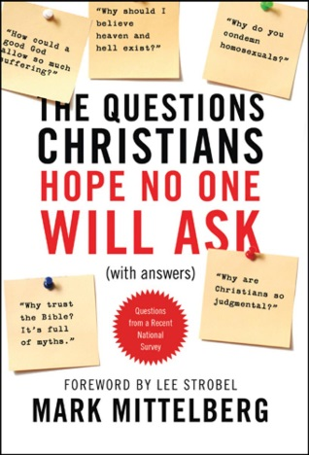
10 Questions Christians Hope No One Will Ask

Question 6: Why is abortion such a line in the sand for Christians—why can’t I be left alone to make my own choices for my body?

Take a few moments and mark the following statements as True or False.

____ Since 1973, there have been almost 60,000,000 abortions in the United States.
____ Abortion has killed far more Americans than all of our country’s wars combined.
____ Over 900,000 abortions are performed each year in the United States.
____ About 85% of women in the U.S. who have abortions are married.
____ Abortion is illegal in the United States after the first trimester.
____ A baby’s heart begins to beat three weeks after conception, usually long before the woman even knows she is pregnant.
____ Brainwaves can be detected in unborn children as early as six weeks after conception.
____ In the United States, unborn children cannot be considered legal persons when their mothers are murdered and cannot be designated as recipients in people’s wills.
____ About 84% of women decide not to have an abortion after seeing the ultrasound of their babies.

Read Psalm 139:13-16

- Discuss these verses with the people around you and decide on several ways you would use them to defend the rights of the unborn.

- “But those verses are part of a psalm! David was just using poetic exaggeration!” How would you respond?

Read Psalm 51:5-6

- What do these verses add to the discussion about abortion?

- Agree or Disagree? Since aborted babies are sinful and don’t have a chance to be baptized, they almost certainly go to hell.

Read Deuteronomy 32:39

- Explain. Abortion is wrong because it claims a right which only God possesses.

- What is the simple answer to the question: “Why can’t I choose to do what I want with my own body?”

- Discuss with the people around you some ways you can answer the following rationalizations for getting an abortion.

- I’m not able to provide a quality life for this child.
- I can’t face the disappointment of my parents and grandparents.
- My body shouldn’t have to endure the stress and changes of pregnancy when I don’t even want the child.
- My friends, relatives, and even my doctor are advising me to do this.
- Why should I have to suffer with pregnancy when my boyfriend gets off completely free?

- Is abortion an acceptable option in cases of rape? What about when the mother’s life is in jeopardy because of the pregnancy? Why or why not?

Read Psalm 127:3-5

- If abortion is so bad, why doesn’t the Bible say more against it?

Read Proverbs 31:8-9

- Agree or Disagree? Christians must always vote against abortion and should speak out publicly against it.

Read Colossians 2:13-15

- What are some reasons these verses are important to keep in mind while discussing abortion?

- Explain. One mistake Christians often make when talking about abortion is focusing only on the unborn child and forgetting about the mother.

“Tell the truth about the evils of abortion, but don’t forget to add the good news that Jesus died for all our sins, including this one, and he wants us to turn away from whatever we’ve done and to come to him for forgiveness, grace, and a new life relationship with him.”
– Mittelberg p. 183

Visit www.christianliferesources.com to learn more about abortion and what our synod is doing about it.

