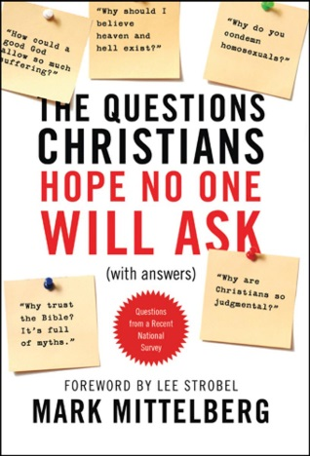
10 Questions Christians Hope No One Will Ask

Question 5: How could a good God allow so much evil, pain, and suffering—or does he simply not care?

“Why, God? Why would you allow this tragedy to happen to me? You said you loved me! Then why am I suffering so much?” Discuss with the people around you some ways you would respond to a person struggling with these questions.

- When someone is in pain and questioning God, what are some reasons it might be a good idea to hold off on trying to answer their questions?

- What else is important to keep in mind when discussing this topic?

“It’s also wise to admit to ourselves that we don’t have a simplistic solution that wraps this problem up in a neat bow and makes everyone feel good. In fact, there’s nothing we can say to make people suddenly okay with the evil around them or the suffering in their lives. Because—let’s be honest—we’re not okay with it, either!” (Mittelberg, p. 138)

- How do we reconcile these three Scriptural truths?
  - God is good and must punish evil.
  - God is all-powerful and can destroy anything that challenges him.
  - Evil still exists today and is constantly challenging God.

Read John 16:33

- What are some reasons it is helpful to know that Jesus predicted trouble for believers?

- In what ways has Jesus “overcome the world”?

Read Genesis 1:31, 2:15-17, and 3:6

- While it’s easy to blame God for the evil in the world today, who do the Scriptures clearly show is actually responsible for evil?

- Discuss with the people around you how the following statement is true: God did not create evil, but he did create the potential for evil. It was necessary if humans were going to be able to exercise free will and show true love.

- In what ways might the following strategy by Mittelberg be helpful?

“God ought to just put his foot down and stop all the madness. When I hear someone say this, I like to ask them which freedoms they think God ought to take away from us right now.” (Mittelberg p. 144)

Read Luke 13:1-5 and John 9:1-3.

- Why are sections of Scripture like these ones such a blessing to people who are suffering?

Read Revelation 21:1-8.

- Discuss with the people around you some ways this section of Scripture could be helpful to a person who is upset about the evil in the world.

Read 2 Peter 3:9.

- Why is God waiting so long to punish evil?

Read Romans 8:28.

- Agree or Disagree? This is a good verse to use with people who are suffering.

Read Isaiah 53:1-9.

- What are some reasons it might be helpful to point suffering people to Jesus’ cross?

Read Romans 8:31-39.

- React to the following statement: We don’t need to know why God allows evil into our lives, it’s enough to know that he loves us.

“My initial suggestion for addressing this topic is to realize that when your friends are experiencing pain they are probably not asking for explanations as much as they’re looking for empathy, concern, and tangible expressions of love. They may be asking, ‘Where was God?’ but mostly be wondering, ‘You say you know God; will you show me his kind of love and care?’” (Mittelberg p. 129)

