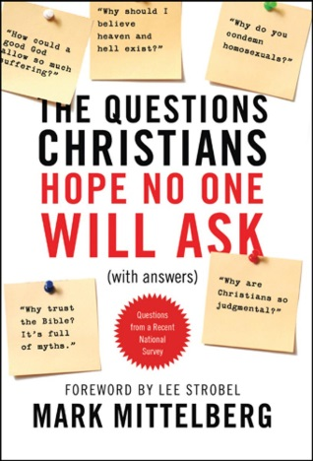
10 Questions Christians Hope No One Will Ask

Question 2: Didn’t evolution put God out of a job? Why rely on religion in an age of science and knowledge?

Discuss the following two questions with the people at your table. What encounters have you had with people who believe in evolution? What were your impressions during or after the experience?

Read Genesis 3:4-5 and Ezekiel 28:2

- Why is evolution so attractive to sinful humans?

Read Deuteronomy 32:39-41

- What is another reason so many people want evolution to put God out of a job?

Read Isaiah 45:21-25

- What are some major problems that result from attempting to remove God from the picture?

Darwin was right at least in this: living things do change and adapt over time—everyone agrees that’s true to some degree. That is, virtually no one denies that microevolution occurs—meaning the adaptations that happen over time within the assorted species. (Mittleberg, p. 30)

- Why must Christians be careful about bashing evolution?

- What is a clear limitation of microevolution that Christians can point out?

So we see that Darwin’s theory of evolution—to even have the chance of getting started in the first place—relies on three essential events that design-oriented views best explain: the origin of the universe, the origin of life, and the origin of information. (p. 44)

Even Darwin himself recognized that the record did not support his thesis, and he even conceded that the lack of transitional examples was one of the greatest objections to his model—but he was confident that further research would eventually fill in the gaps. If he had been right, then surely all the searching and digging over the 150 years since he first published The Origin of Species would have yielded countless transitional fossils. Yet to this day there is a complete lack of solid, undisputed examples. (p. 53)

- What would be some advantages of pointing out these limitations to an evolutionist? What would be some disadvantages?

Science is not—or at least it does not have to be—an atheistic enterprise that rules out the possibility of influences from intelligent sources beyond the normal order of nature. We can stay open to all of what science shows us—not limiting our conclusions to merely naturalistic ones. (p. 35)

- Defend: Automatically ruling God out of the picture is actually very unscientific.

Read Genesis 1:20-31

- Discuss with the people at your table the following question: In what ways is the Genesis creation account a more beautiful truth than the theory of evolution?

“True science must follow the facts wherever they lead. And in this case, they seem to lead quite persuasively back to God and his creative activities.” – Mittelberg, p. 37

